Experiment (1)
Review on IPs and Subnetting
1.1 Objectives

1.2 Equipment / Program Requirements:

1.3 Experiment Setup:

1.4 Simulation Results:

1.5 Conclusions:

Experiment (2)
Static Routing and Configuration
2.1 Objectives

2.2 Equipment / Program Requirements:

2.3 Experiment Setup:

2.4 Simulation Results:

2.5 Conclusions:

Experiment (3)
RIPv2 Routing and Configuration
3.1 Objectives

3.2 Equipment / Program Requirements:

3.3 Experiment Setup:

3.4 Simulation Results:

3.5 Conclusions:

Experiment (4)
EIGRP Routing and Configuration
4.1 Objectives

4.2 Equipment / Program Requirements:

4.3 Experiment Setup:

4.4 Simulation Results:

4.5 Conclusions:

Experiment (5)
OSPF Routing and Configuration
5.1 Objectives
UnderStanding OSPF
Learn how To Config Routers With OSPF
Advertise directly connected networks using OSPF
Verify OSPF configuration using different show commands..
5.2 Equipment / Program Requirements:

eNSP
Cisco Packet Tracker

5.3 Experiment Setup:
The network topology consists of two routers connected together using an Ethernet link.
Each router is connected to a PC to form two different LANs.

- Router 1 is connected to PC1.
- Router 2 is connected to PC2.
- The two routers are connected using a direct link.

IP addressing is configured as follows:
- Network between routers: 11.0.0.0/30
- LAN 1: 10.0.0.0 /24
- LAN 2: 12.0.0.0/24
OSPF is configured on both routers in Area 0 to enable dynamic routing and allow communication between the two LANs.
5.4 Simulation Results:
Cisco Packet Tracker Topology:

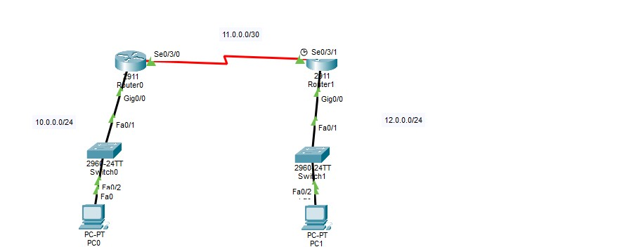
Router1 Configuration:
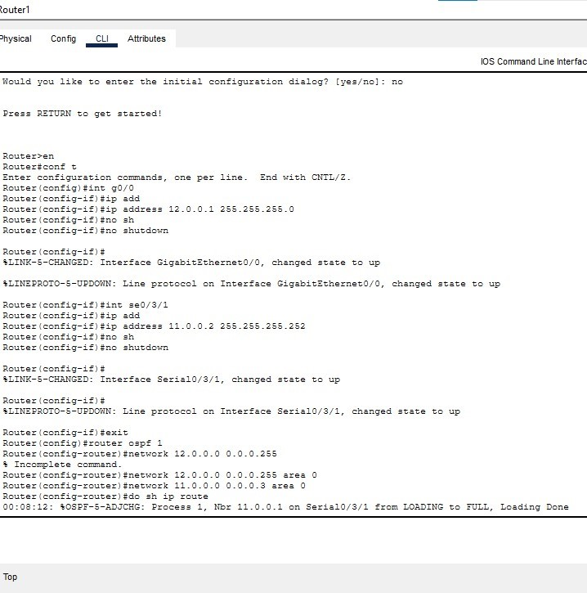

Router1 Route Table,OSPF, LSDB:
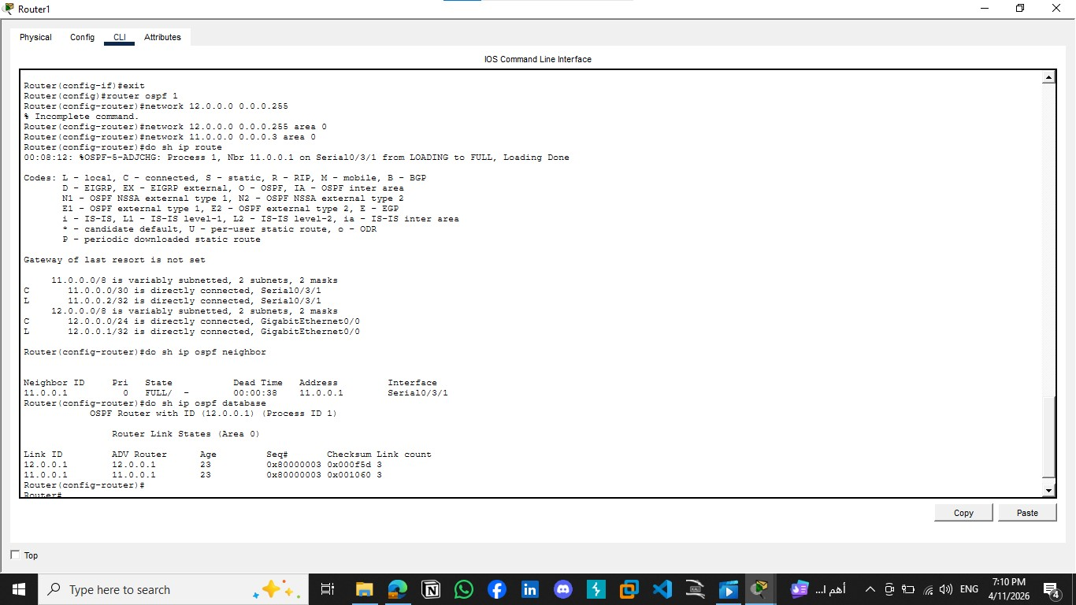
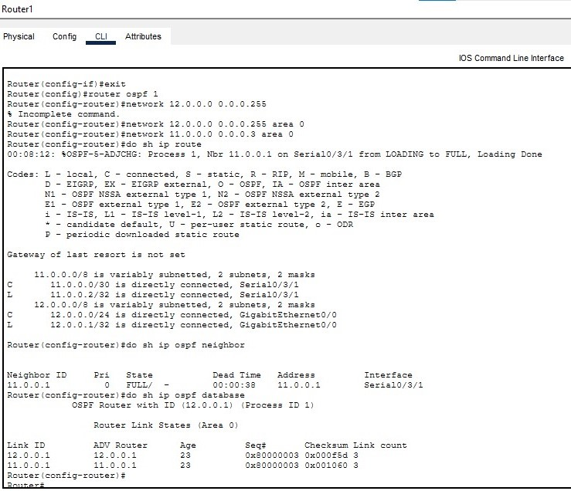

Router 0 Configuration:
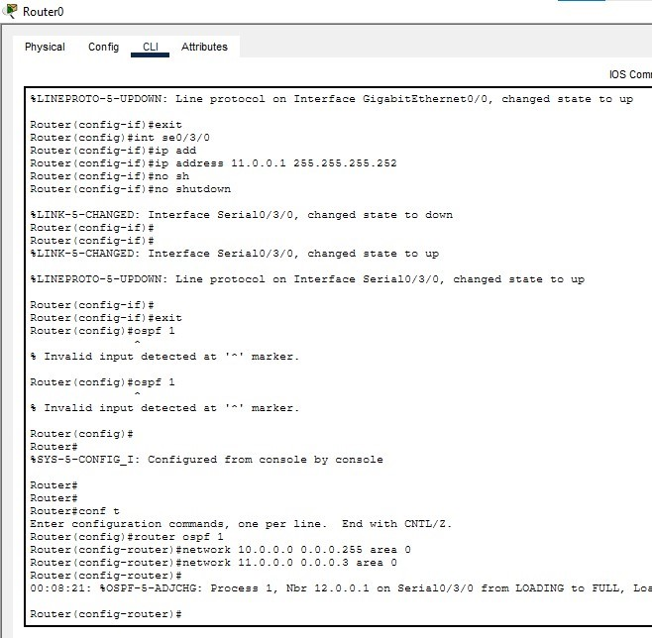

Router 0 Route Table , OSPF , LSDB:
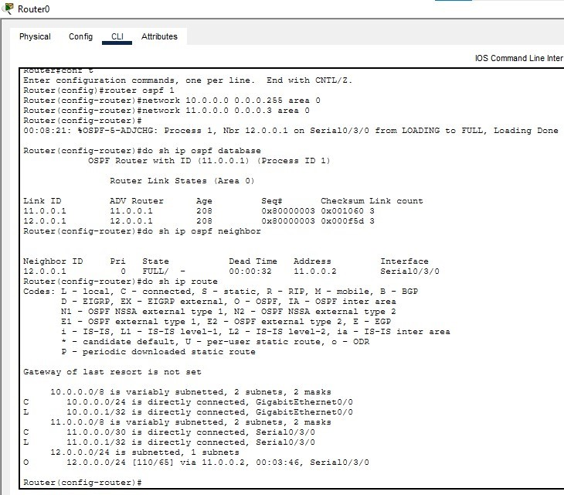

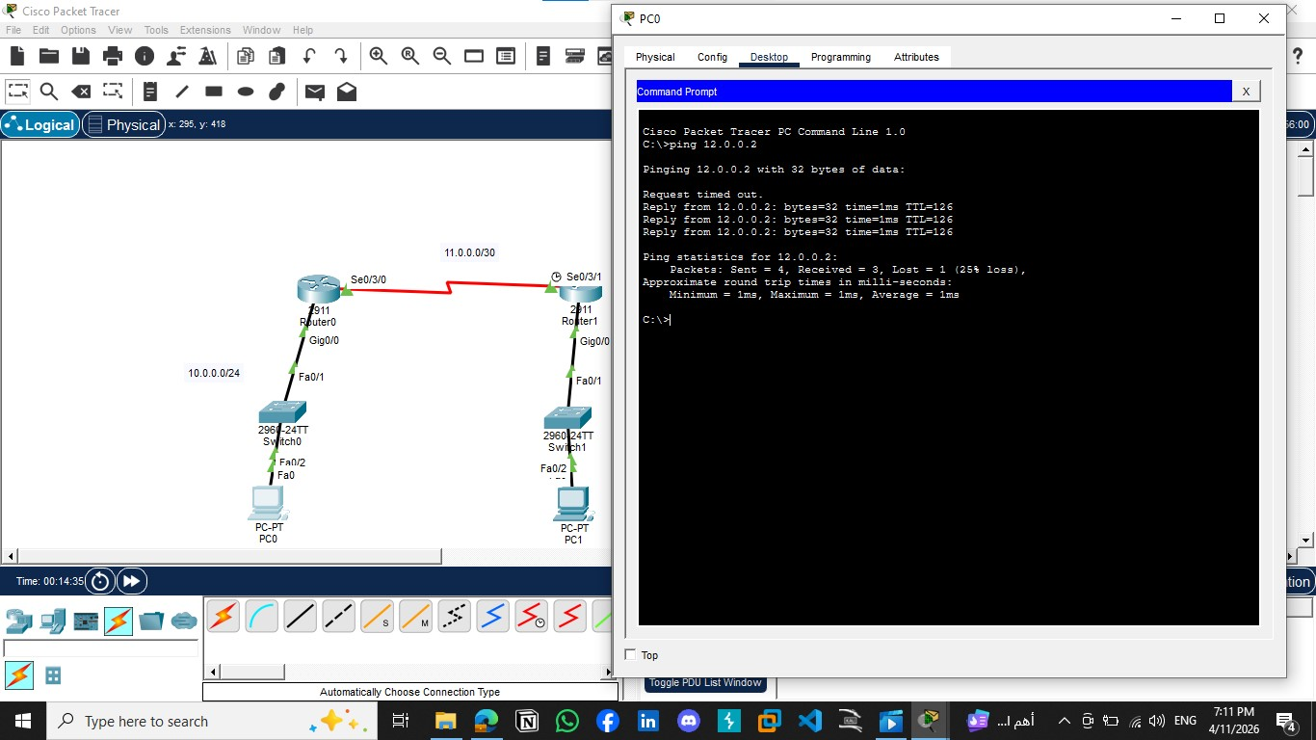

eNSP:
Topology:
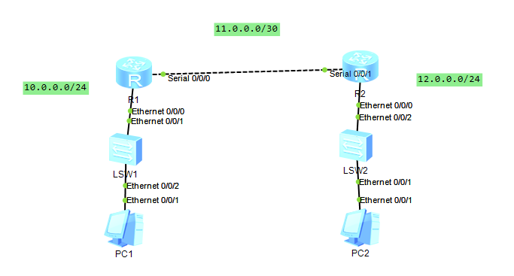

Configuration On R1:
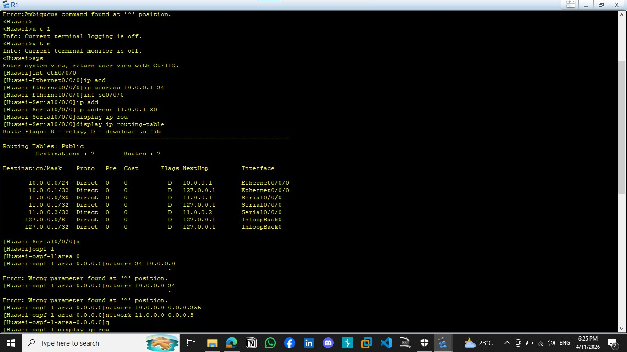

Configuration On R2
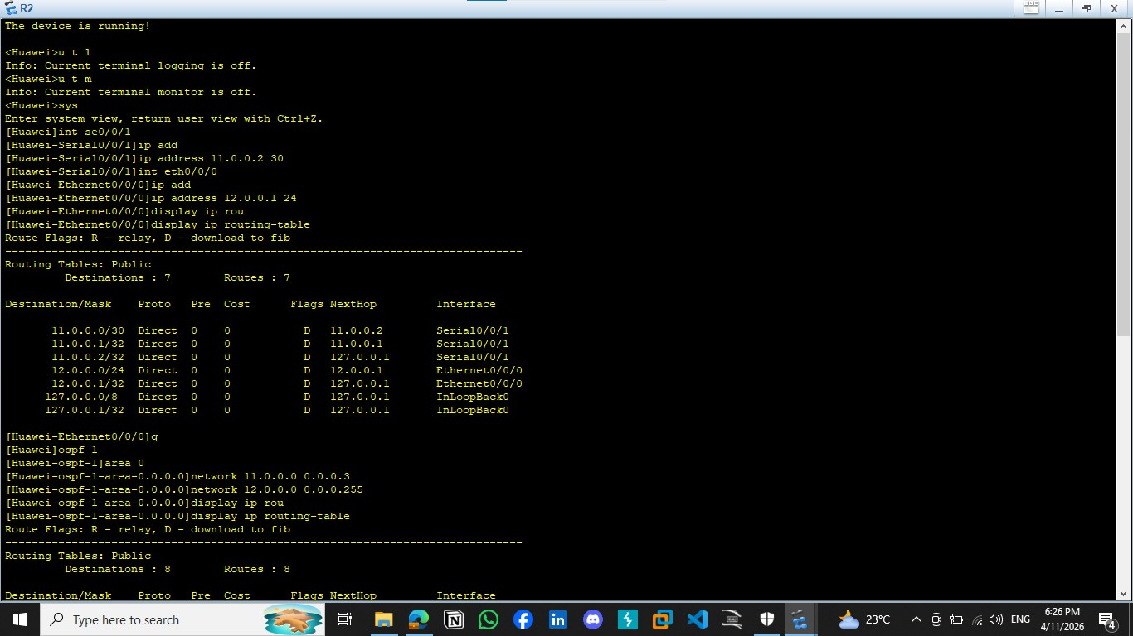

Routing Table For R1
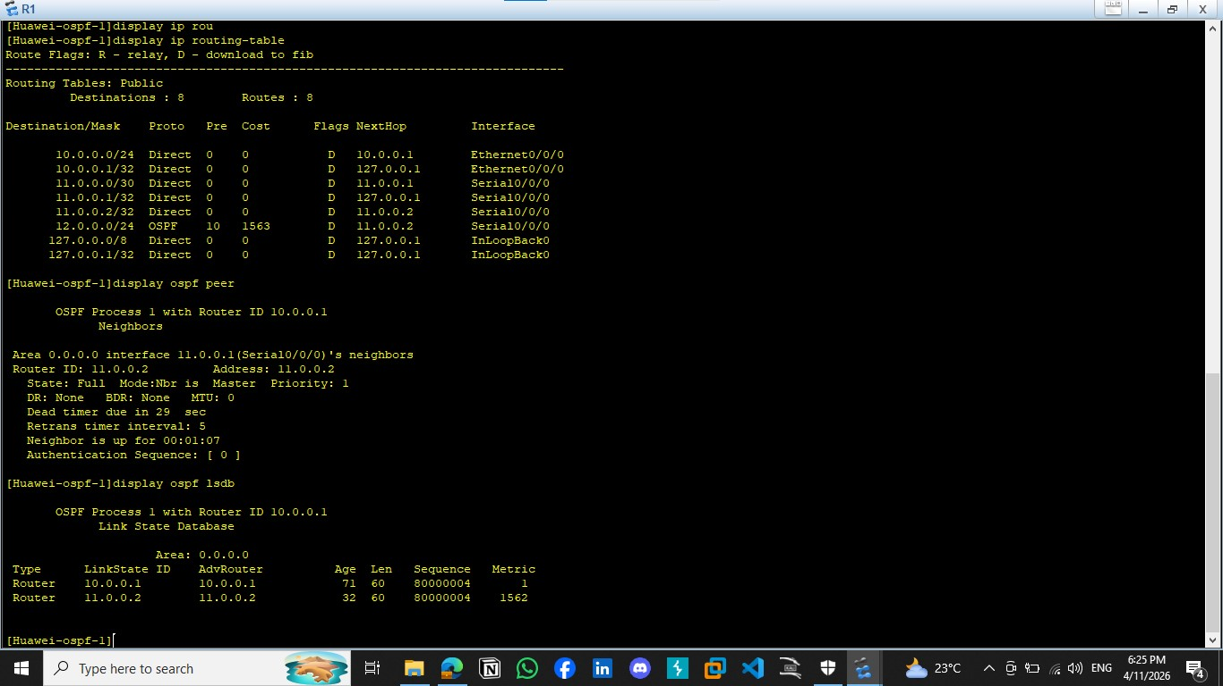
Routing Table For R2

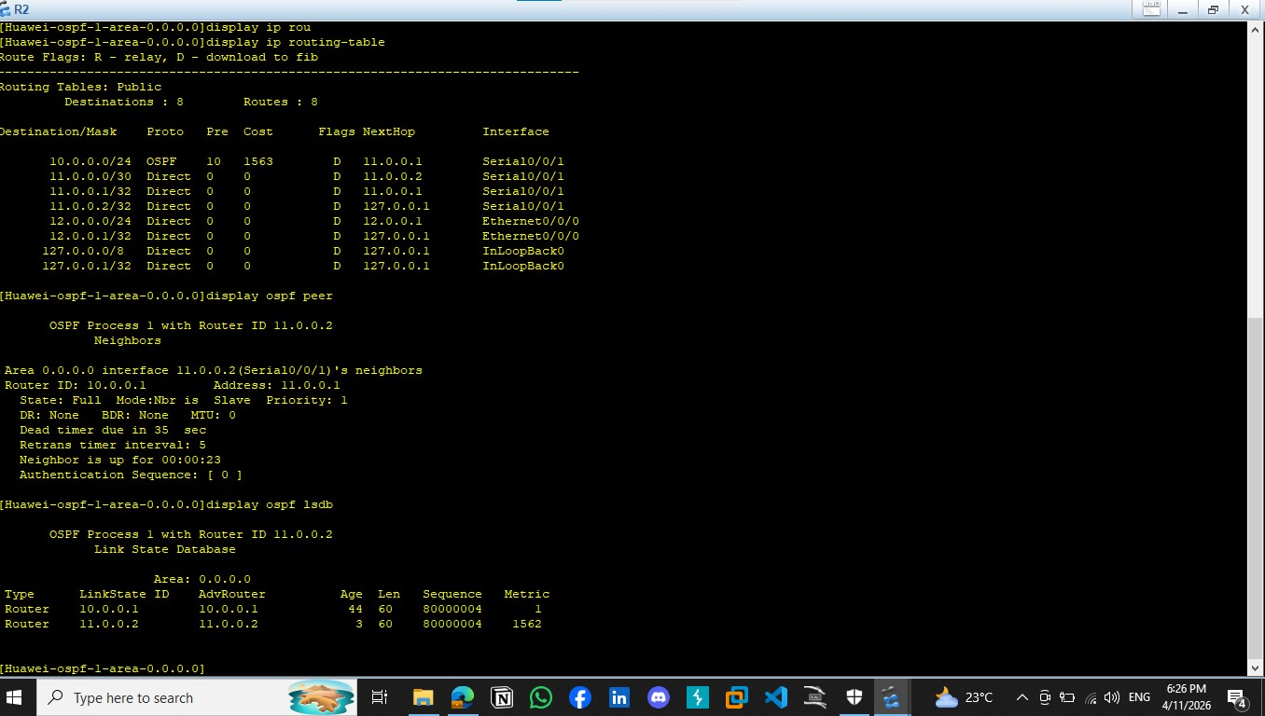

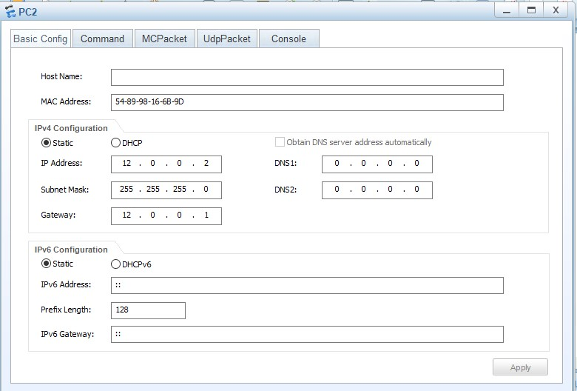

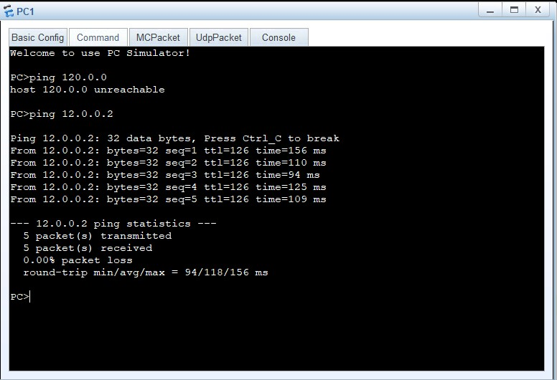
5.5 Conclusions:
The OSPF protocol allowed automatic route exchange between routers, which enabled successful communication between different LANs
OSPF is more efficient than static routing in large and complex networks.
Experiment (6)
Telnet
6.1 Objectives
To achieve Telnet protocol and understanding mechanism of it’s work

6.2 Equipment / Program Requirements:
Ensp
Cisco Packet Tracker

6.3 Experiment Setup:
First make topology as shown under
Second devide it to 3 areas different and achieve ospf protocol and make configuration of ips in each router
Third enable telnet protocol with username and password
6.4 Simulation Results:

Topology:
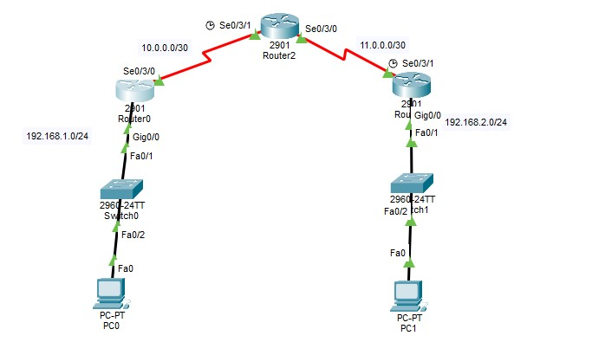

Router0 Configuration:
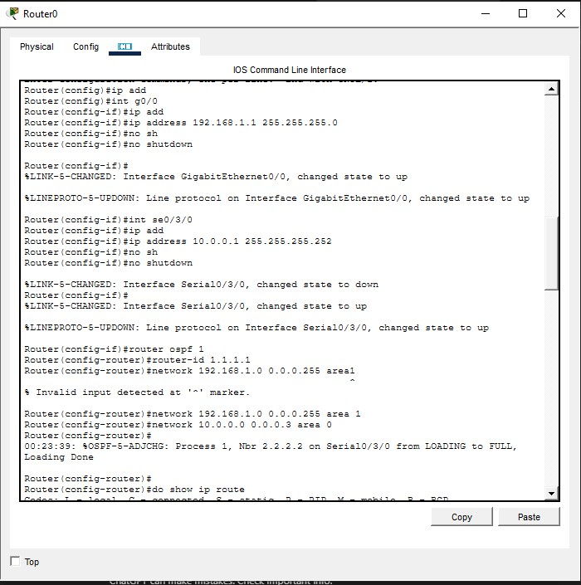

Router0 Ospf database:
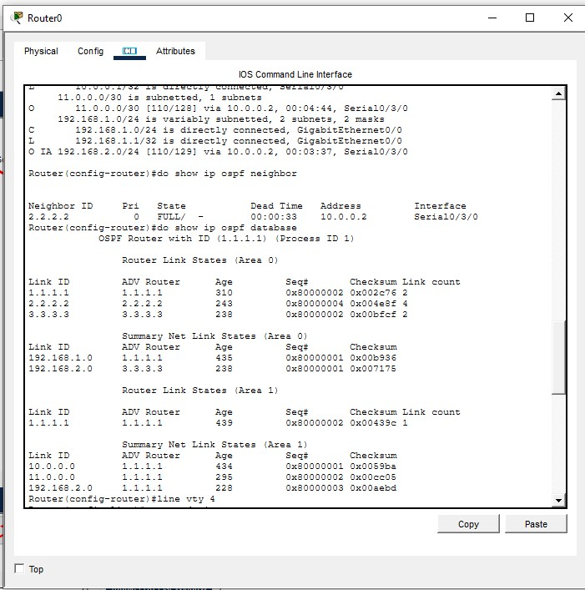
Router0 routing table:
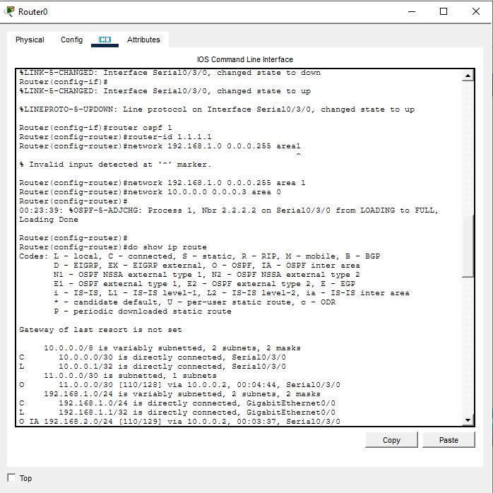

Router1 configuration:
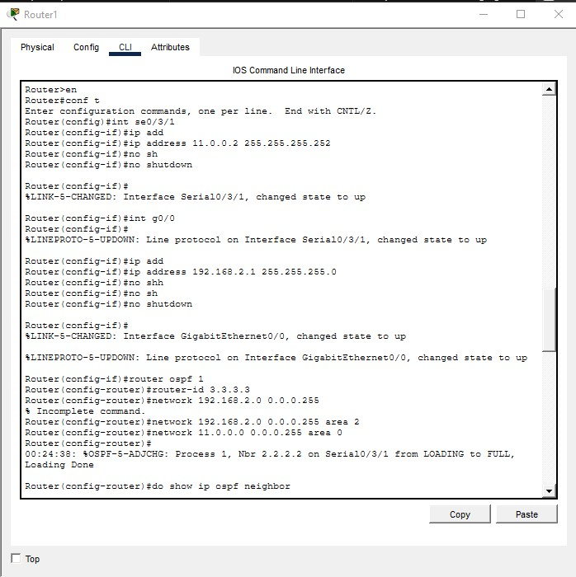

Router1 routing table:
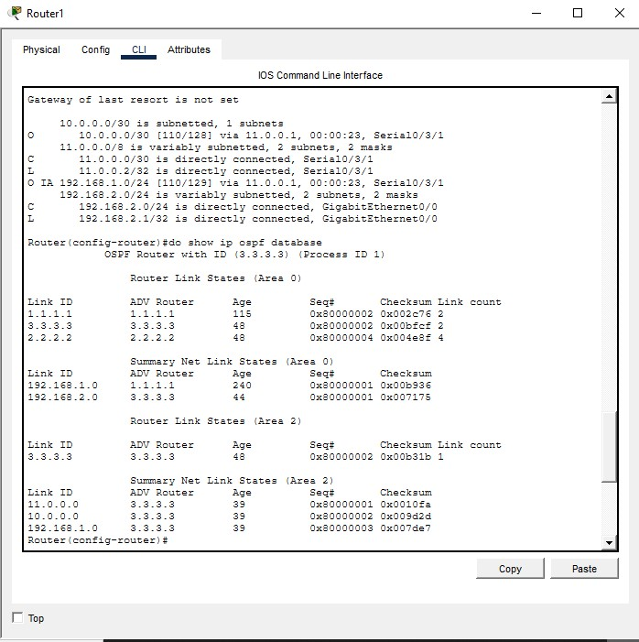

Router2 configuration:
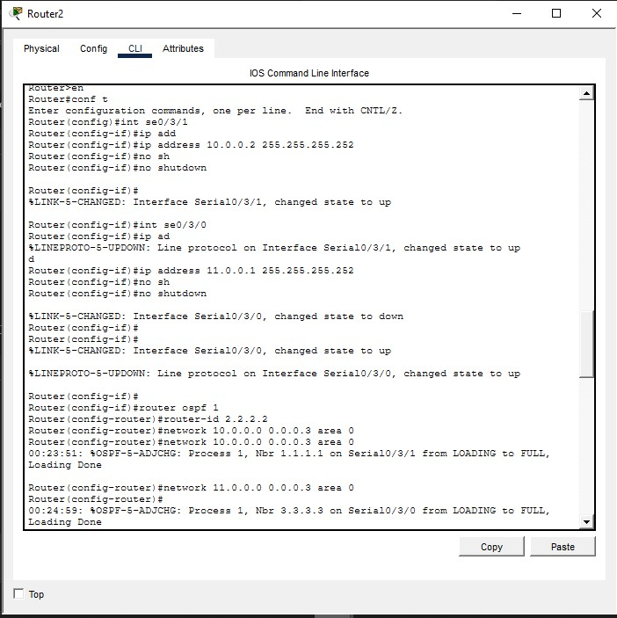

Router2 ospf database:
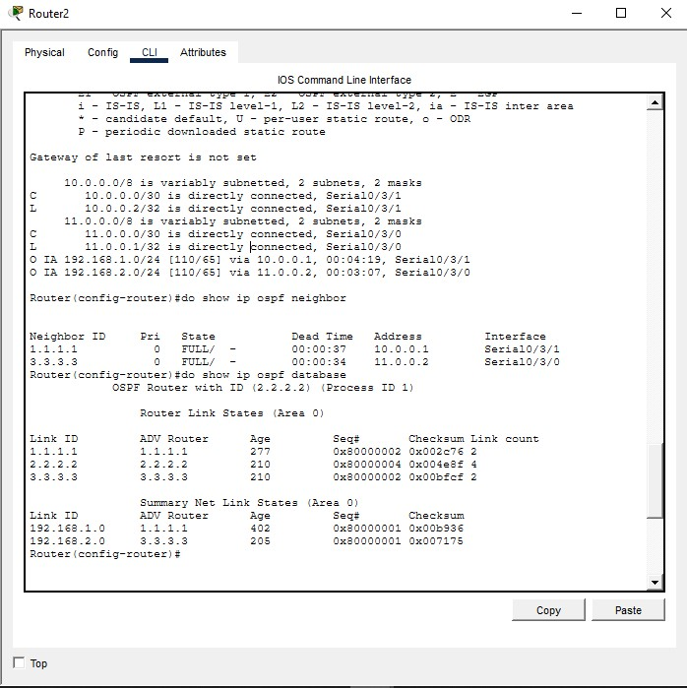

Router2 routing table:
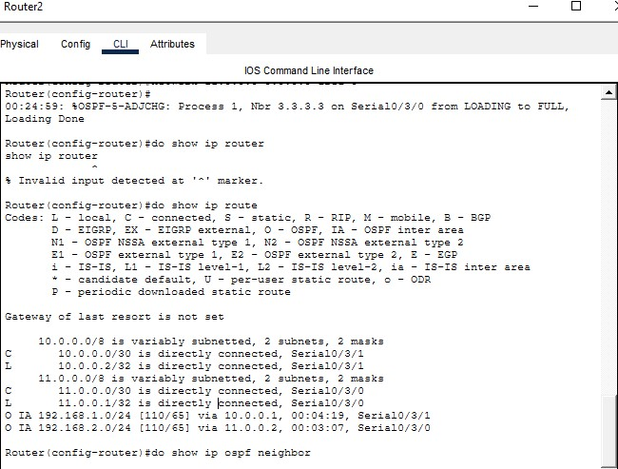
Telnet & Testing with Ping Protocol:
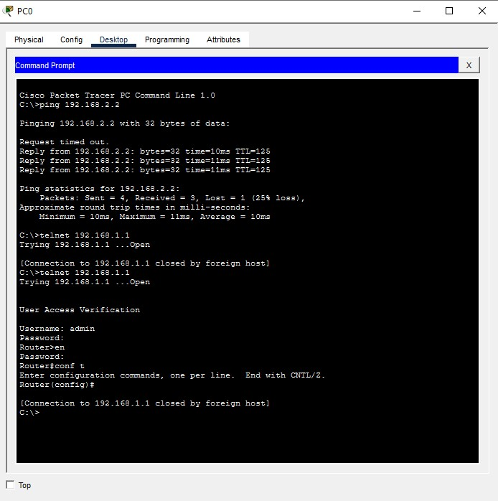

6.5 Conclusions:
It’s Important to use Telnet Protocol to make remote access to other devices

Experiment (7)
Wide Area Network (WAN)
7.1 Objectives

To achieve Encapsulation between 2 Routers

7.2 Equipment / Program Requirements:

ENSP

7.3 Experiment Setup:

Make topology as shown then make encapsulation then ping between 2 routers to check connections
7.4 Simulation Results:

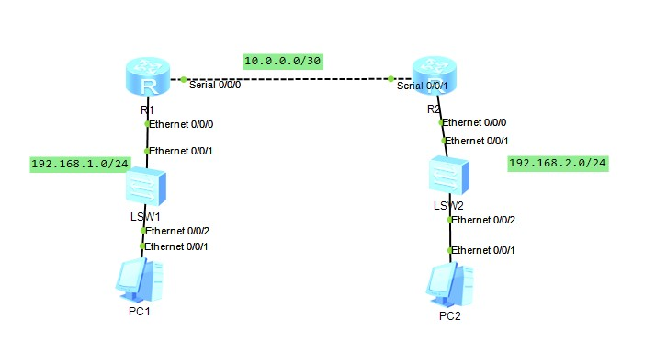

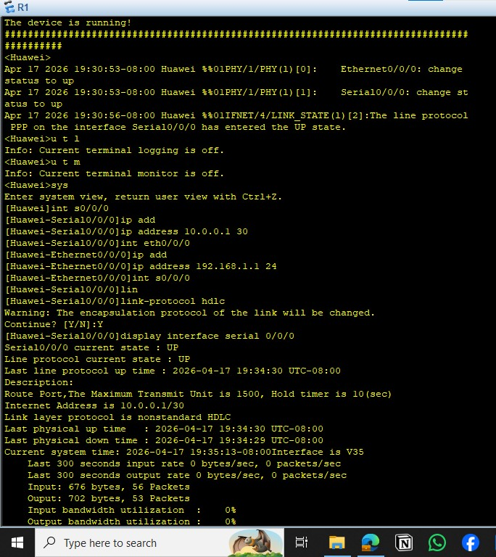

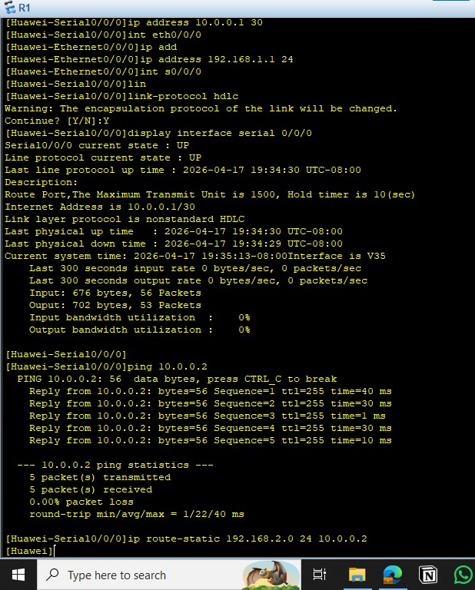

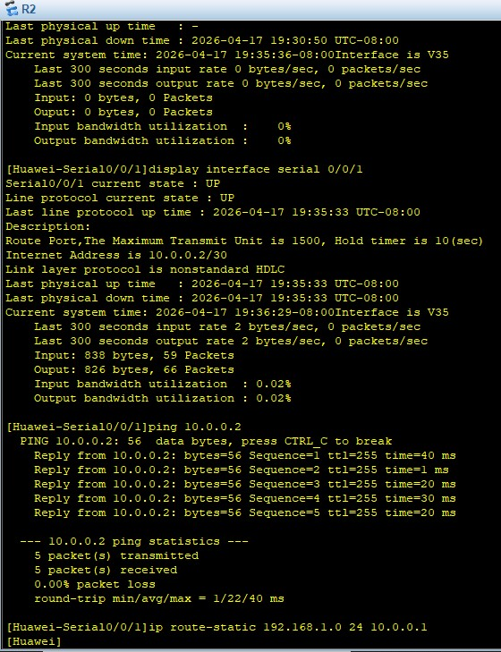

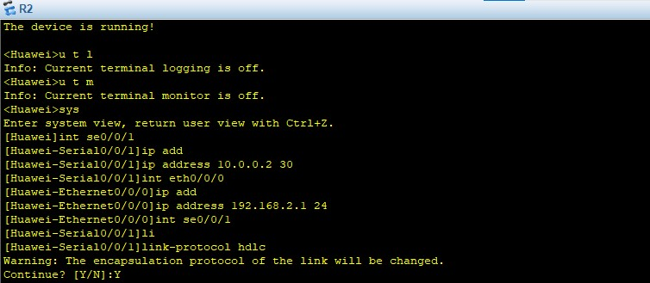

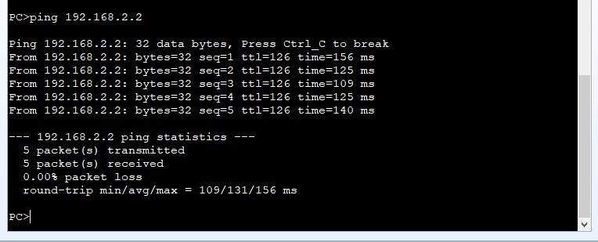

7.5 Conclusions:
Encapsulation Is important for 2 routers to move data between 2 routers

Experiment (8)
Virtual Private Network (VPN)
8.1 Objectives

To achieve VPN Usage

8.2 Equipment / Program Requirements:
Cisco Packet Tracker
eNSP

8.3 Experiment Setup:
1- make topology as shown
2- then make configuration
3- check vpn
4- ping to test
8.4 Simulation Results:

eNSP:
R4:
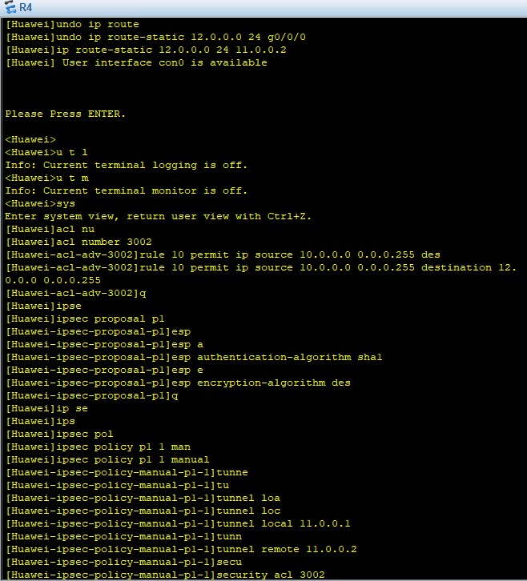
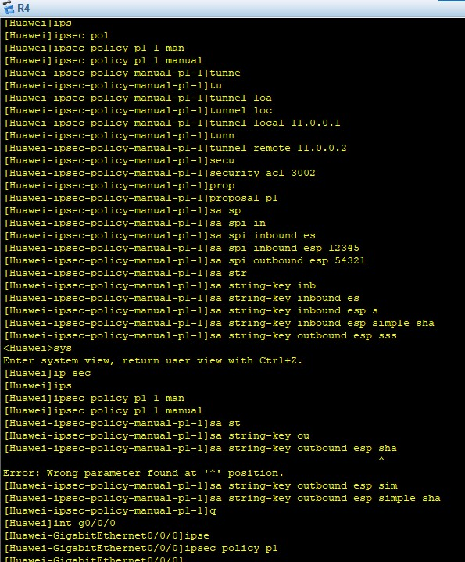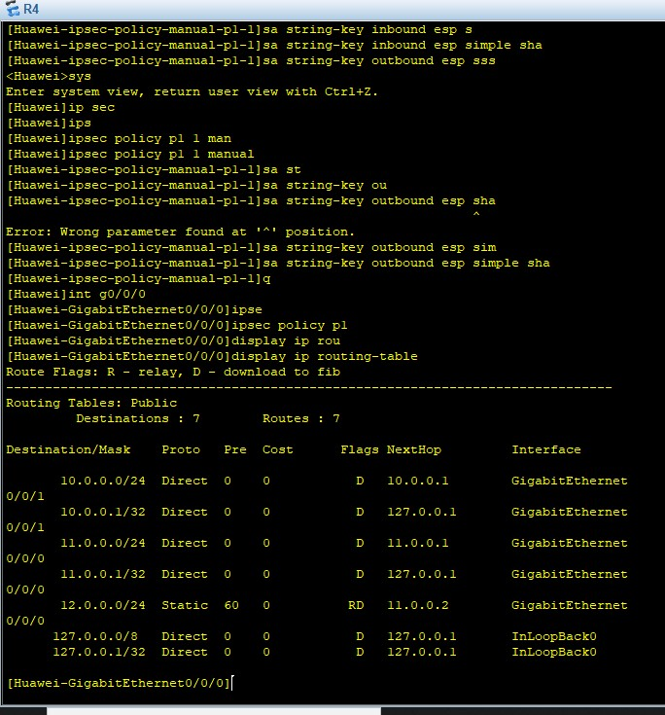
R5:
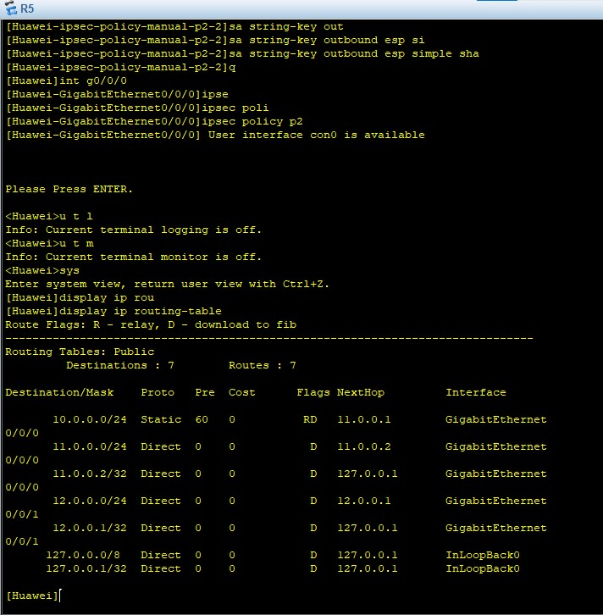
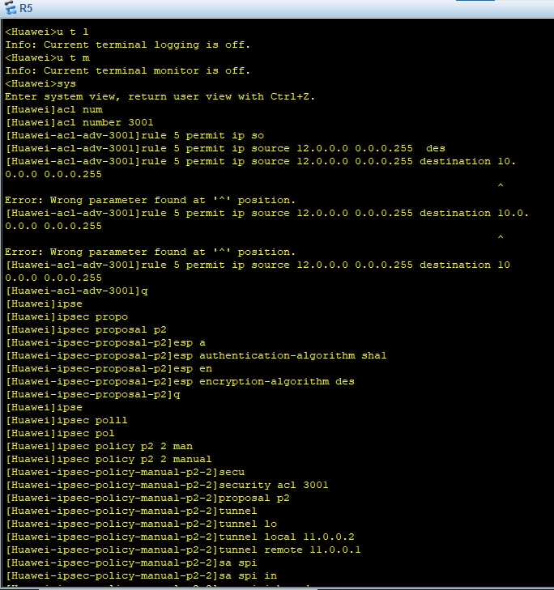
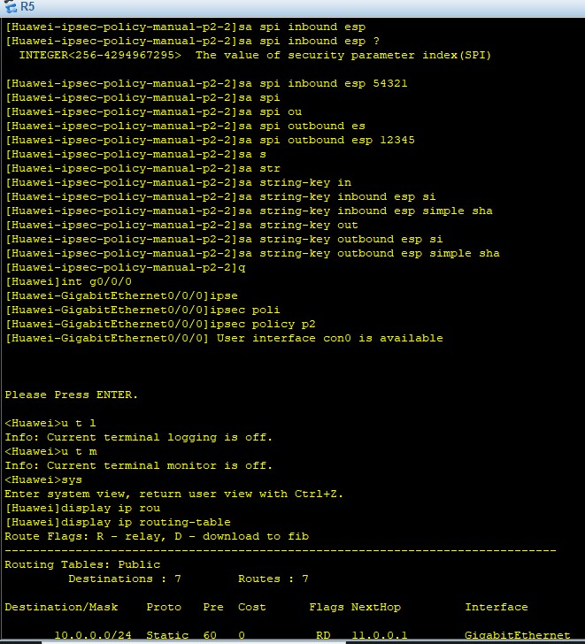
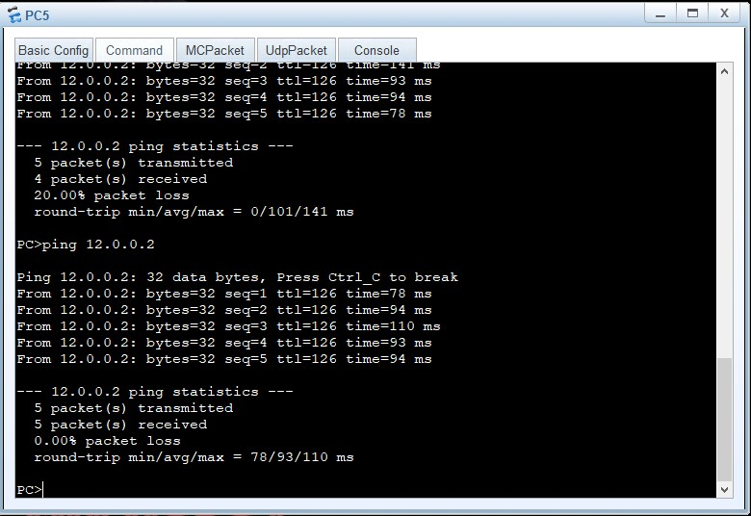
Wire shark doesn’t work with me
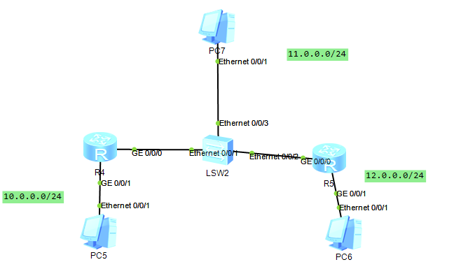
Cisco Packet Tracker:
R6:
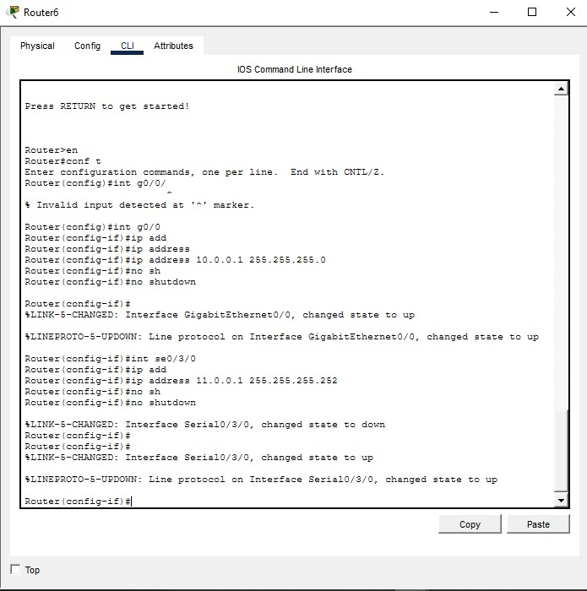
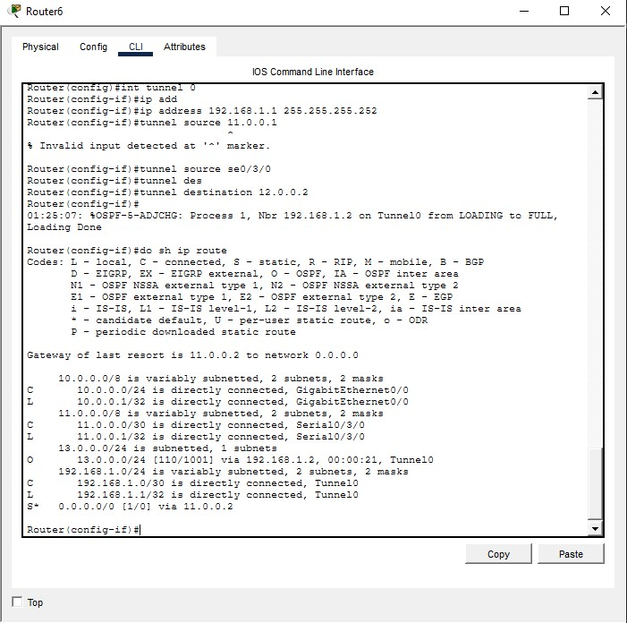
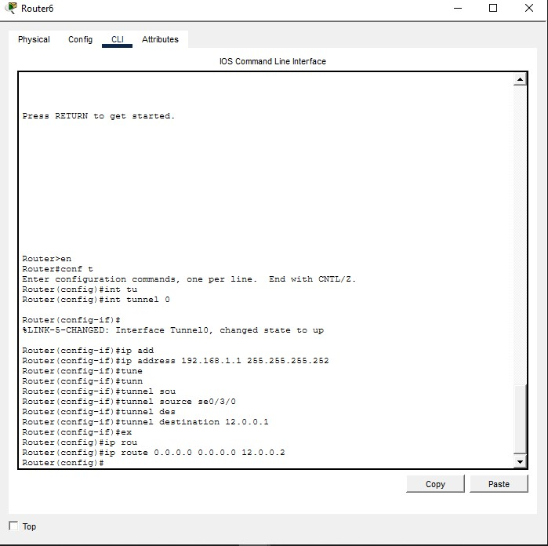
R7:
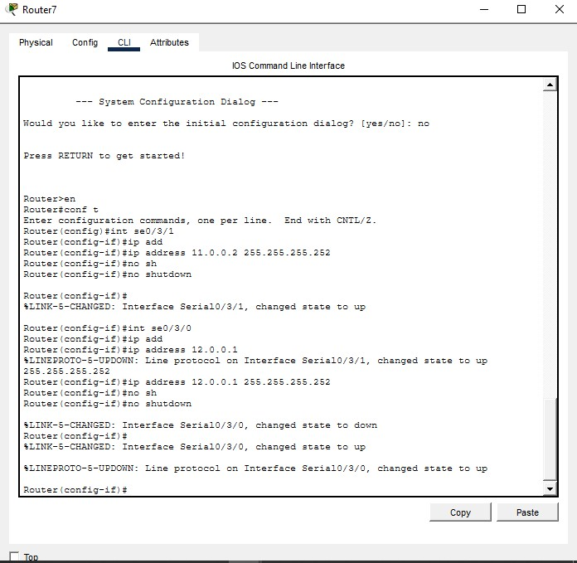
R8:
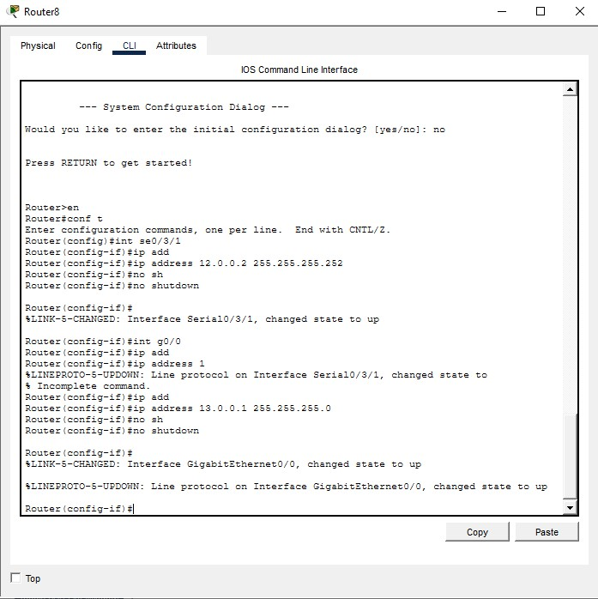
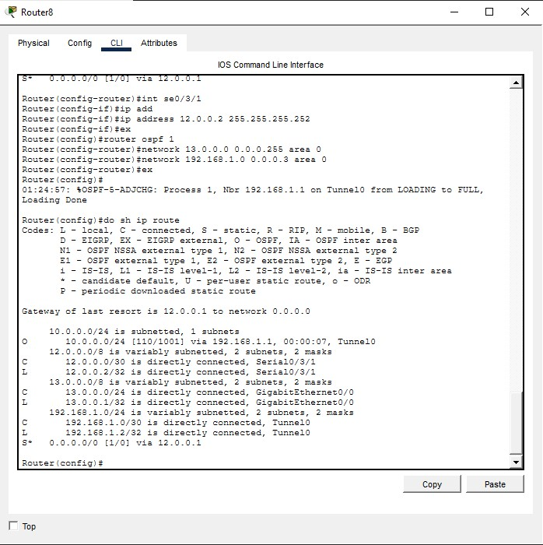
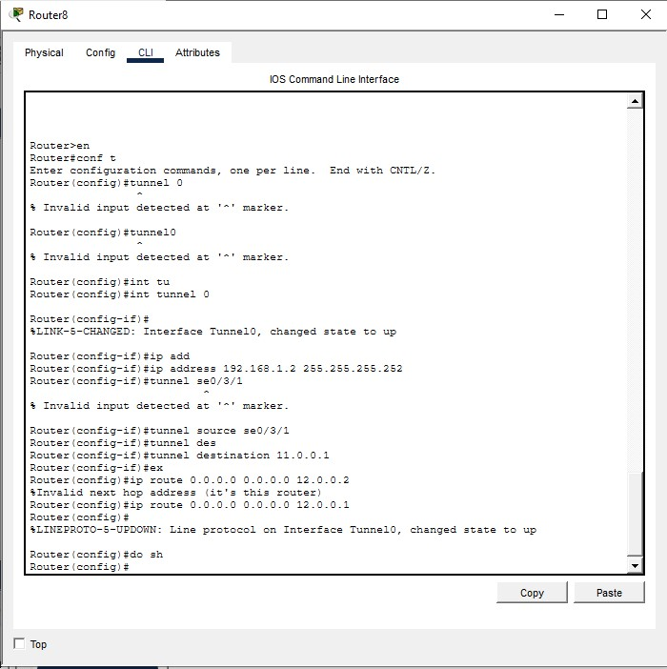
Topology:
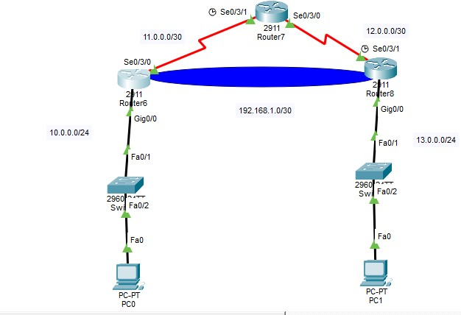
Testing:
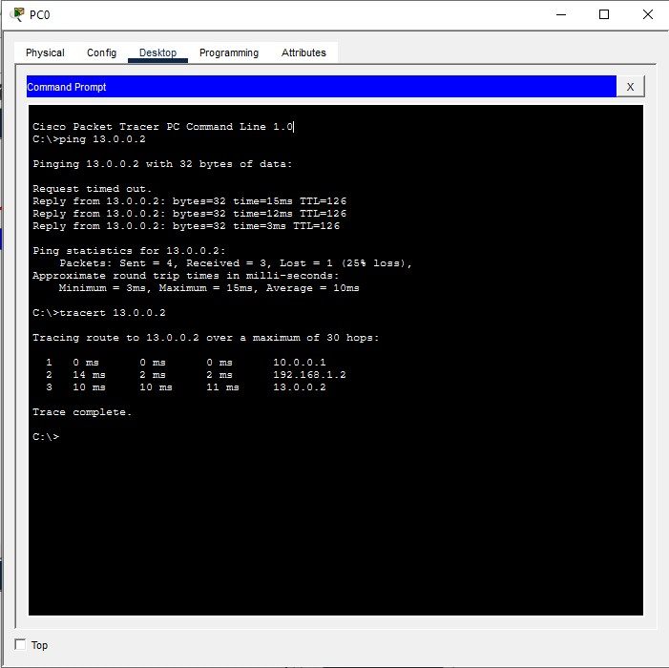

8.5 Conclusions:
The Importance Of VPN is to make your connection secure , encrypted , we can’t deny importance of vpn in our life in enterprises , companies as we show in out experiment.

Experiment (9)
Spanning Tree Protocol (STP)
9.1 Objectives
To achieve importance of STP in Cisco Packet Tracker & eNSP

9.2 Equipment / Program Requirements:
Cisco Packet Tracker
eNSP

9.3 Experiment Setup:
Open Simulator
Then make 3 Switches and do configurations to know Root Switch,non Root Switches , DP Ports ,and BW Ports in cable.

9.4 Simulation Results:
Cisco Packet Tracker:
Topology:

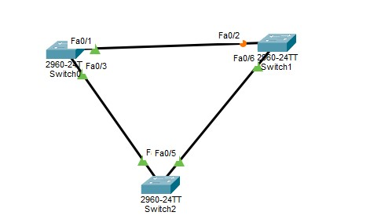

SW2 is root in the First Before I force SW1 become root switch:
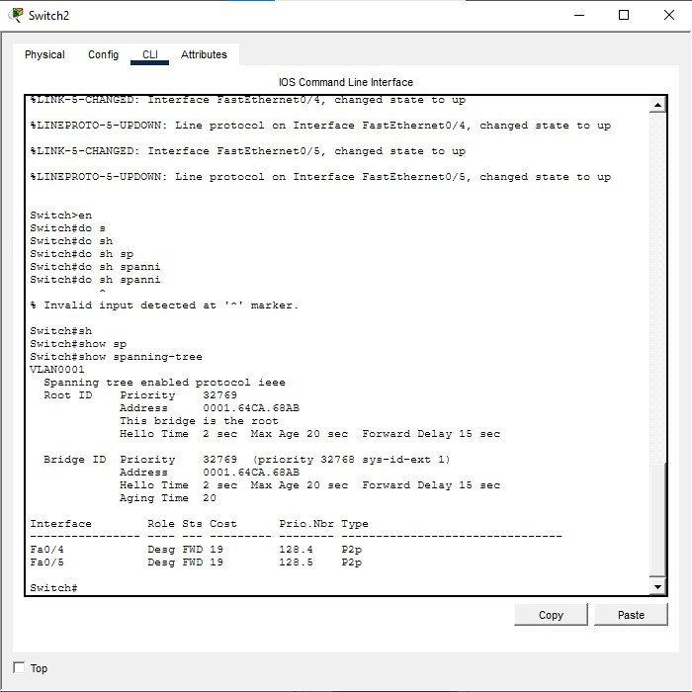

Sw1:
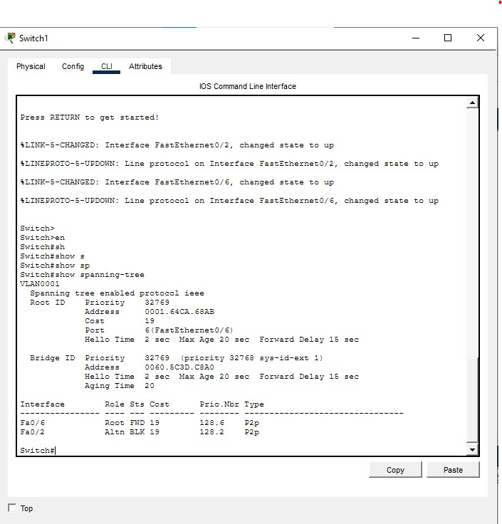

Sw 0:

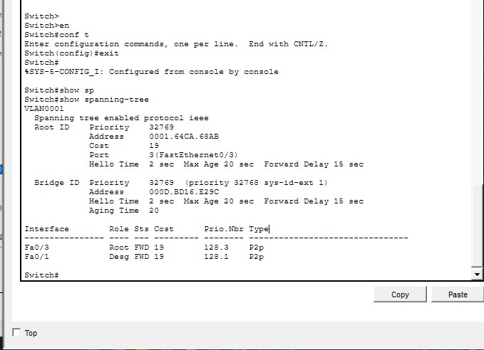
For sw1 make it root switch ( forced ):

Sw1(config)#spanning-tree vlan 1 priority 0
Then wait 50 second
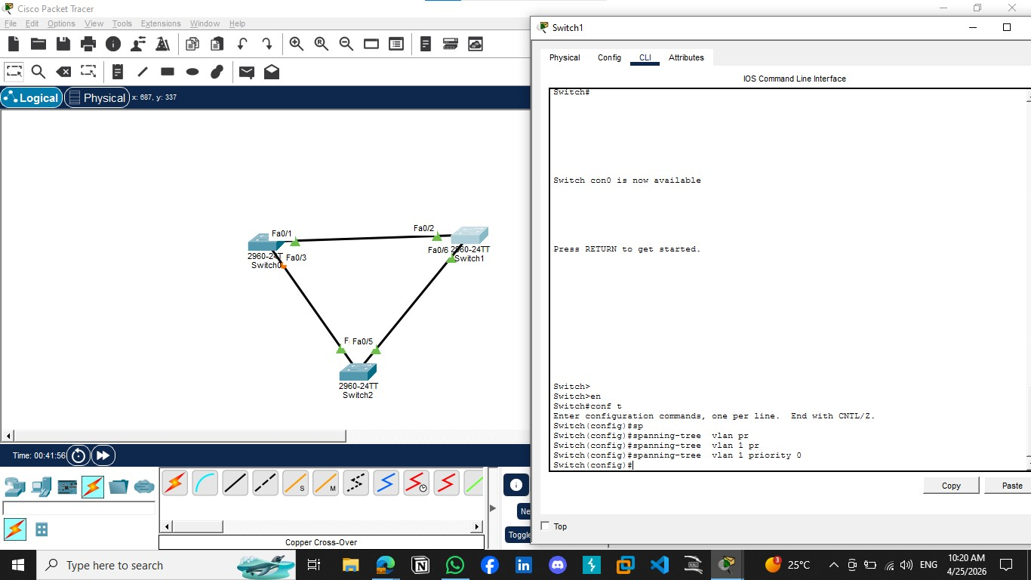
eNSP:
Topology:

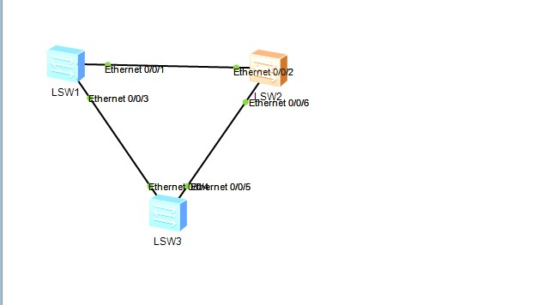
SW1:
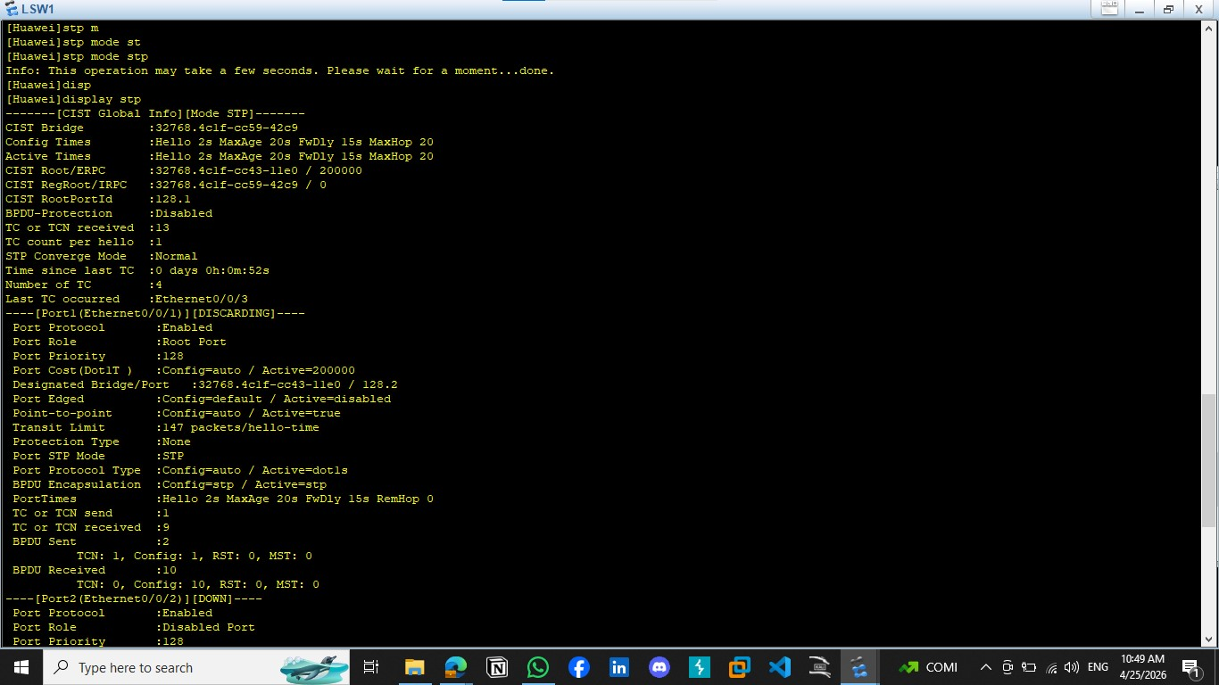

SW2:
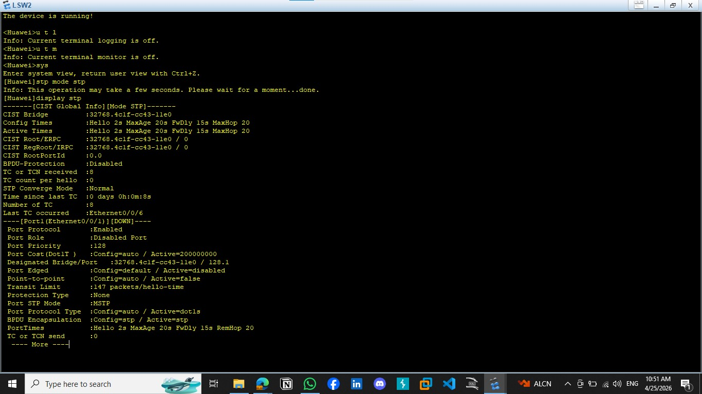

SW3:
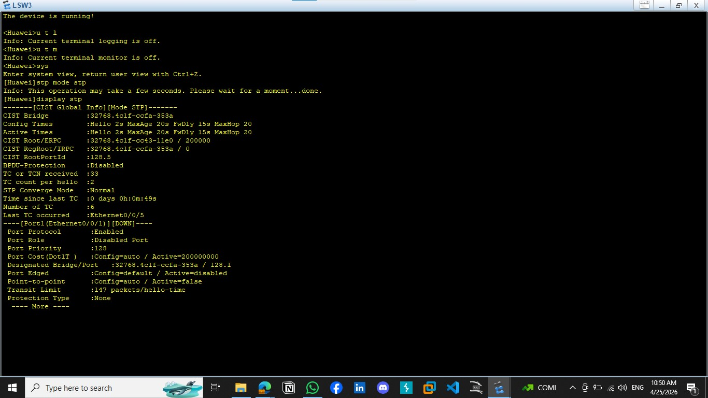
9.5 Conclusions:
Spanning Tree Protocol (STP) is essential in Layer 2 networks because it prevents switching loops that can cause broadcast storms, MAC table instability, and network fail\ure.By creating a loop-free logical topology

Experiment (10)
Border Gateway Protocol (BGP)
10.1 Objectives

To achieve imporance of BGP
Border Gateway Protocol (BGP)

10.2 Equipment / Program Requirements:
Ensp
Cisco packet tracker

10.3 Experiment Setup:
Make topology
Then put ips for each device
Then configuration BGP Protcol Interior
Then Ping For Troubleshooting

10.4 Simulation Results:
Cisco Paket Traker:
Topology
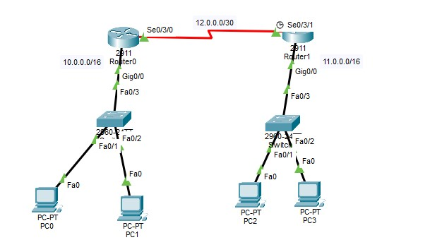

Router 0 Configurtaion:
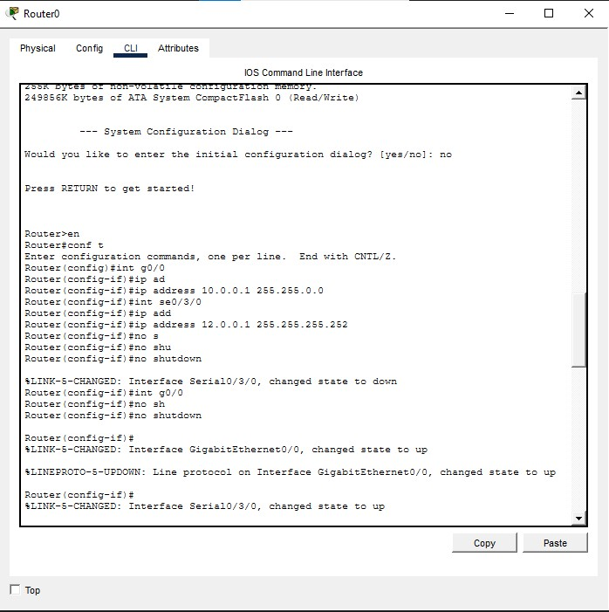

Router 0 Routing Table :
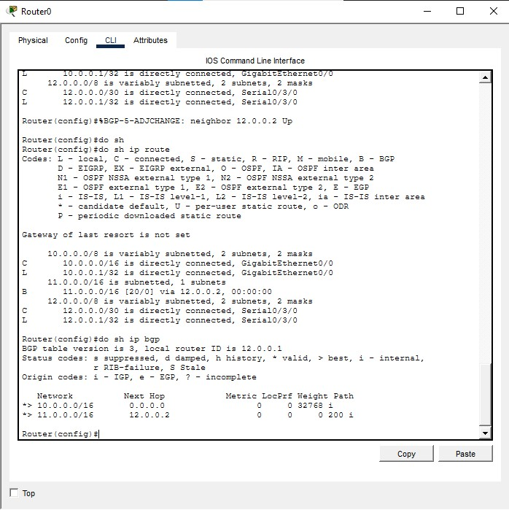

Router 1 Configuration:
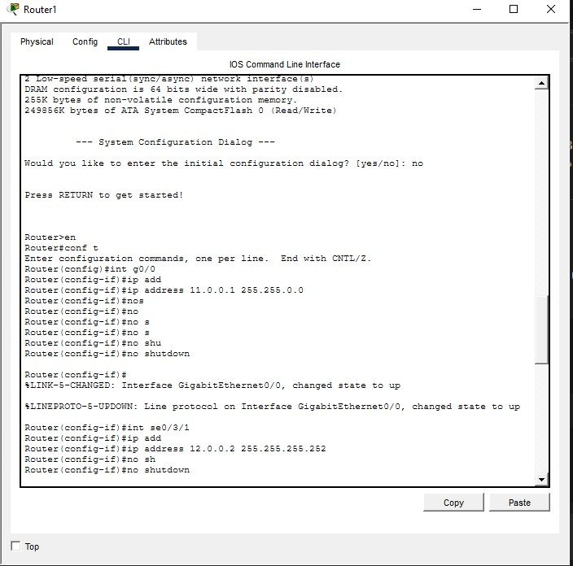

Router 1 Routing Table:
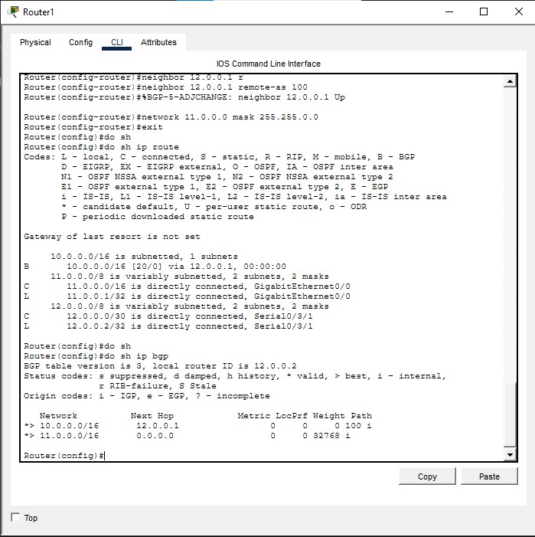
Testing:
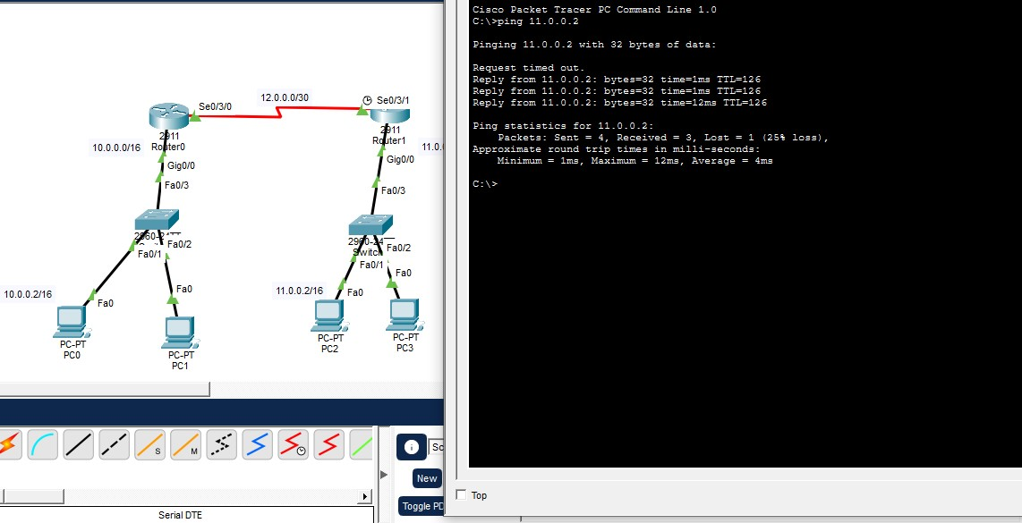
eNSP:
Topology:
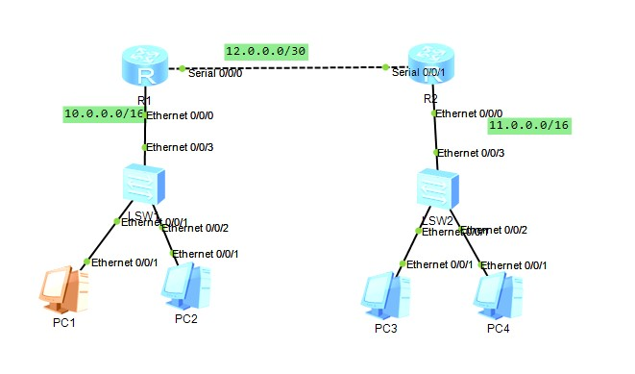
R1 Configuration:
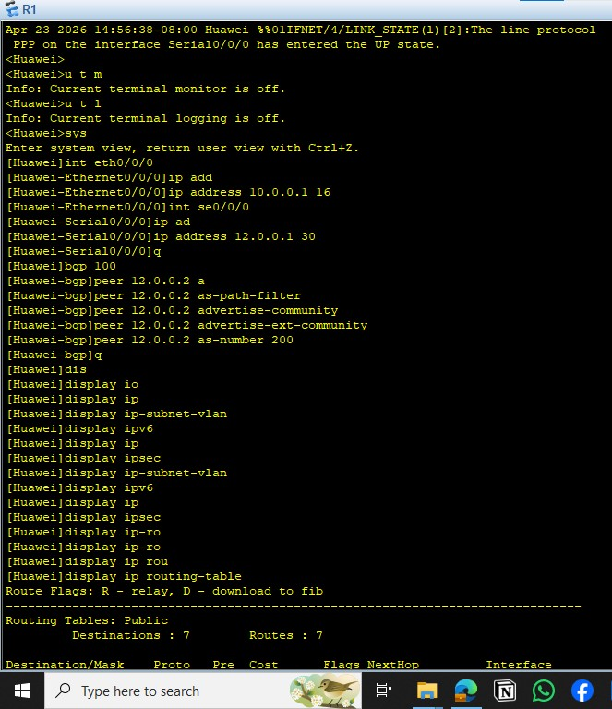

R1 Routing Table:
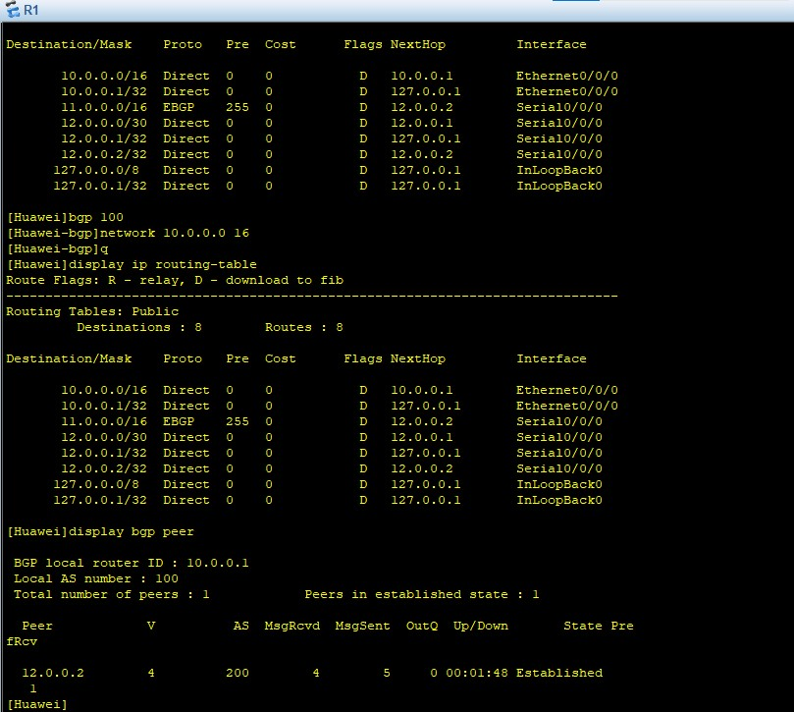

R2 Configuration:
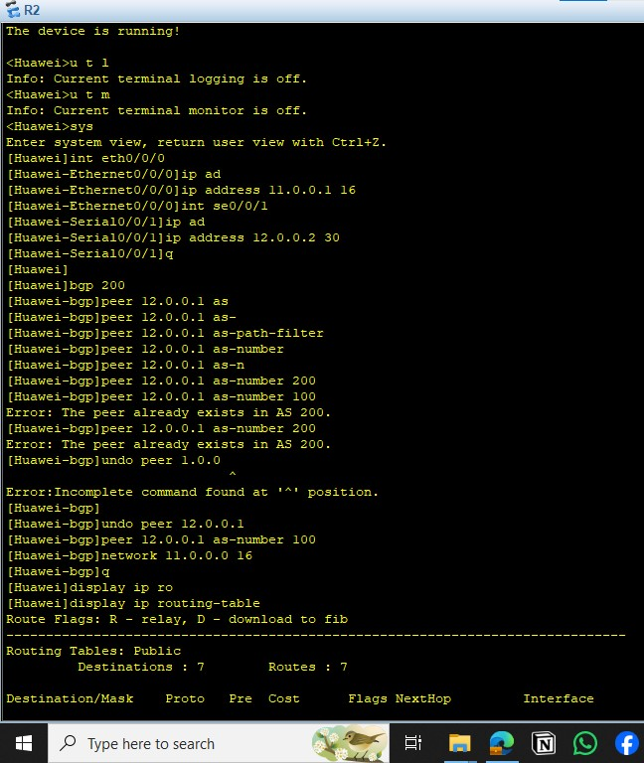

R2 Routing Table:
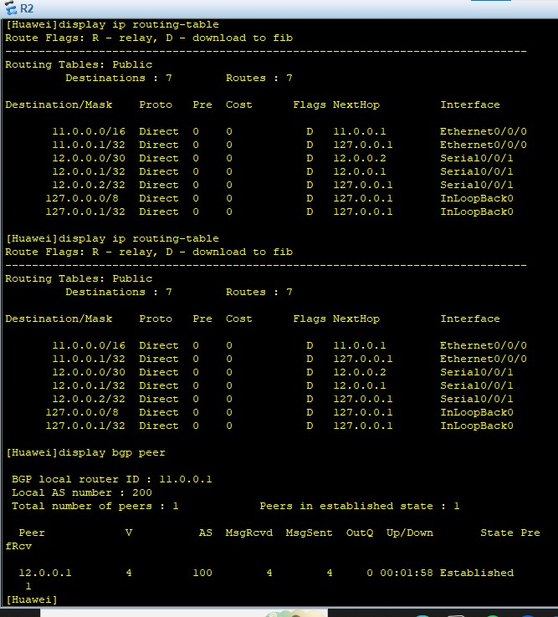

Testing:
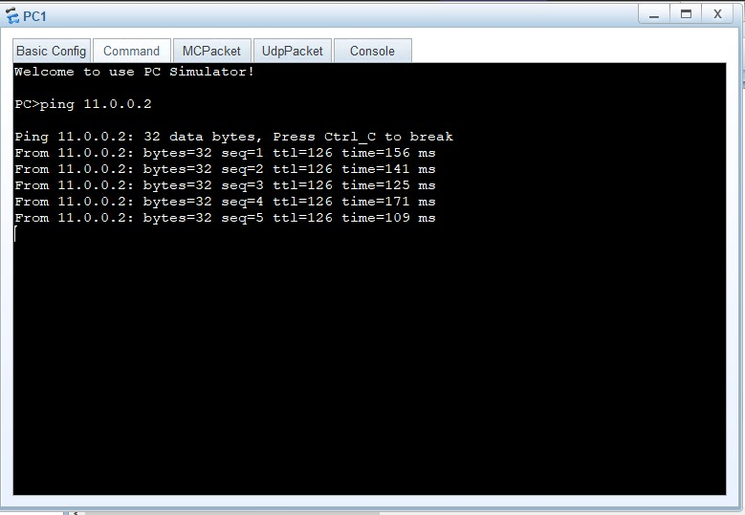

10.5 Conclusions:
Border Gateway Protocol (BGP) is the core routing protocol of the Internet, responsible for connecting different Autonomous Systems (AS).
It uses a path vector mechanism to select the best route based on attributes such as AS-Path and Next-Hop, rather than just the shortest path.
BGP is highly scalable and supports policy-based routing, which allows network administrators to control how traffic flows between networks.
However, it is more complex to configure compared to other routing protocols like OSPF or RIP.

Experiment (11)
Virtual Local Area Network (VLAN)
11.1 Objectives

To achieve Importance Of VLAN

11.2 Equipment / Program Requirements:
eNSP
Cisco Packet Tracker

11.3 Experiment Setup:
Draw your topo
Then make configuration
Then display vlans in topology
11.4 Simulation Results:

Cisco Packet Tracker:
Topology:
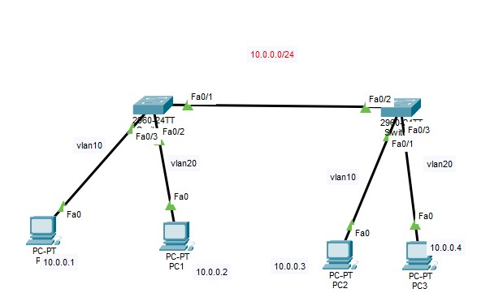

SW 0:
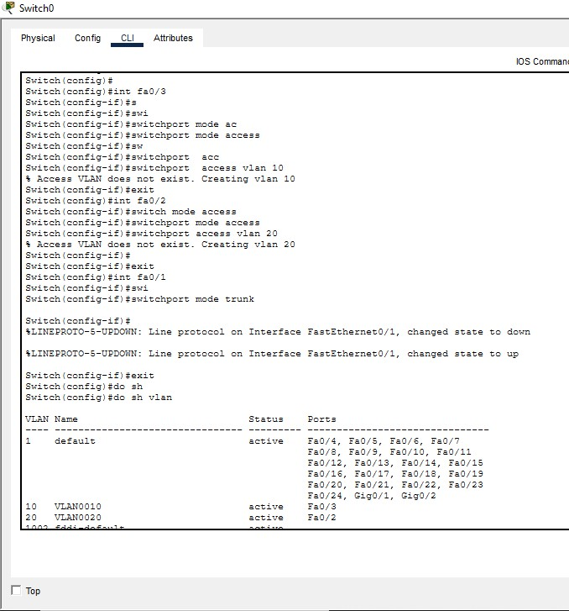
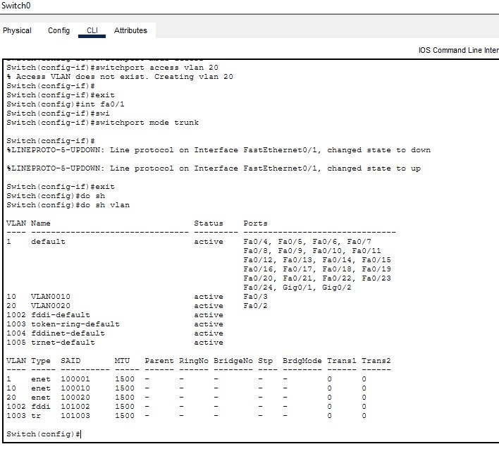

SW1:
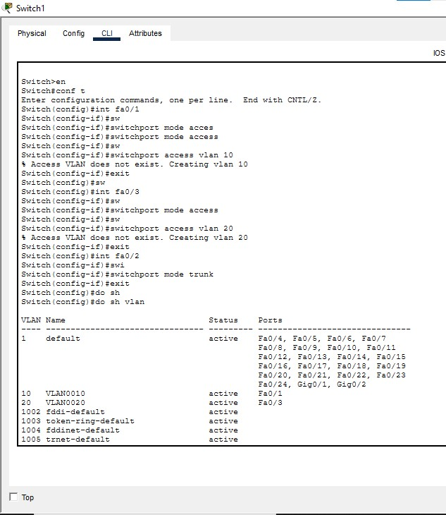

Testing:
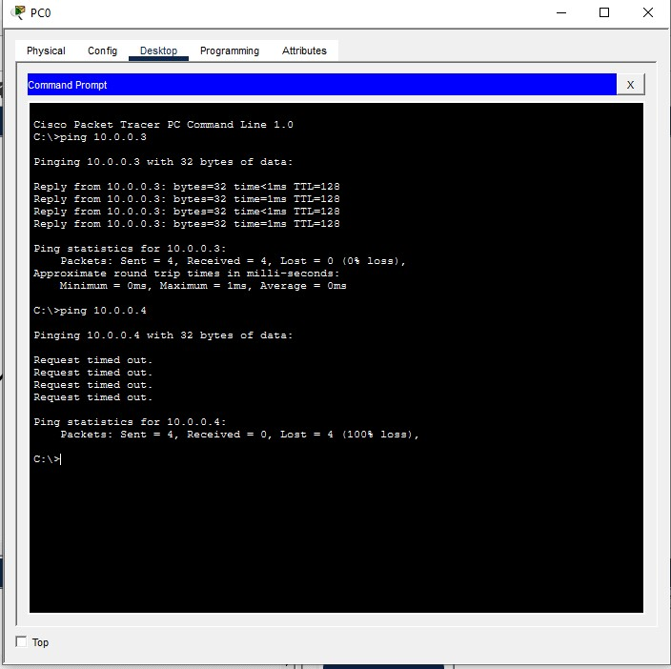

eNSP:
Topology:
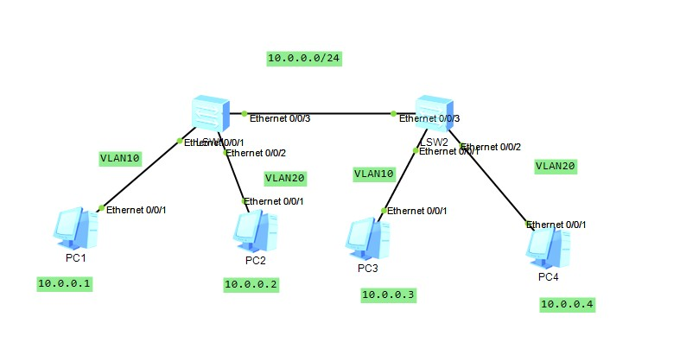
SW1:
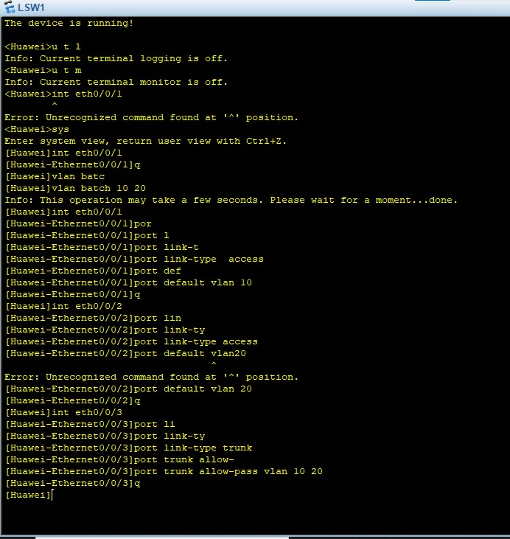
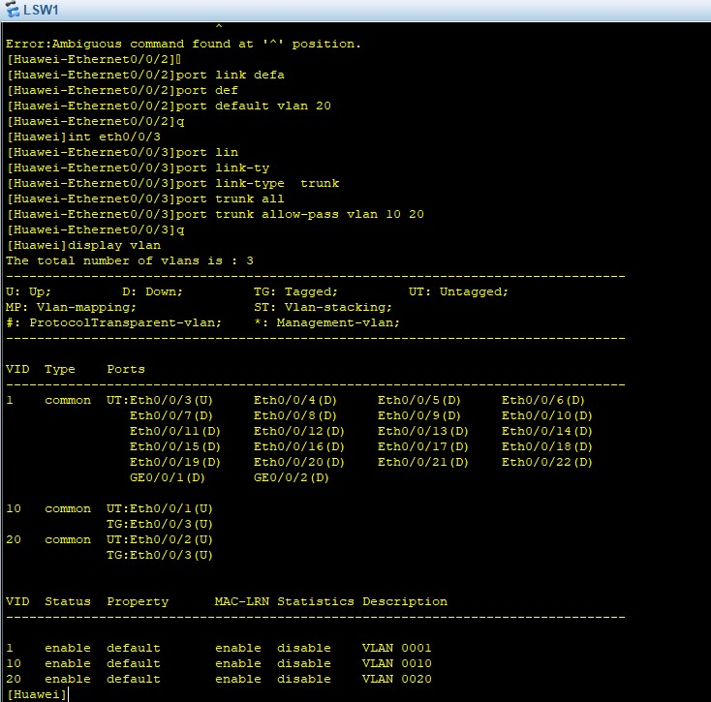

SW2:
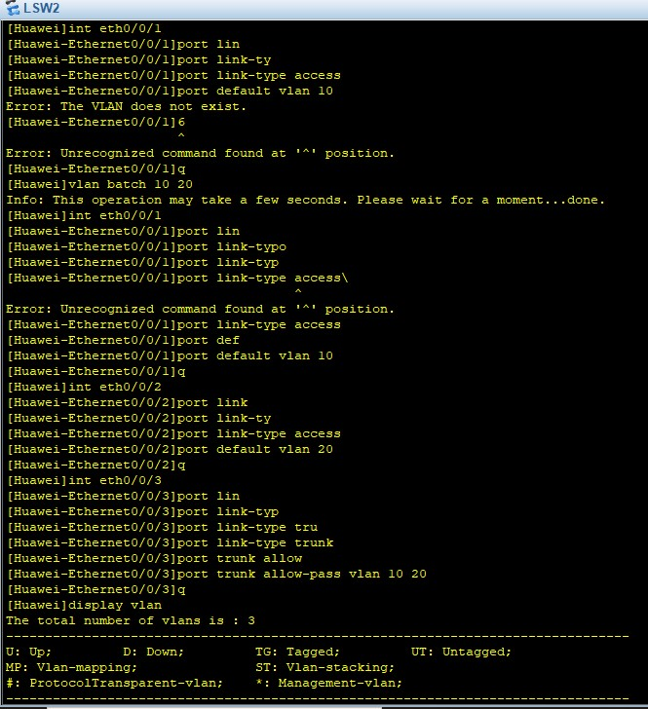
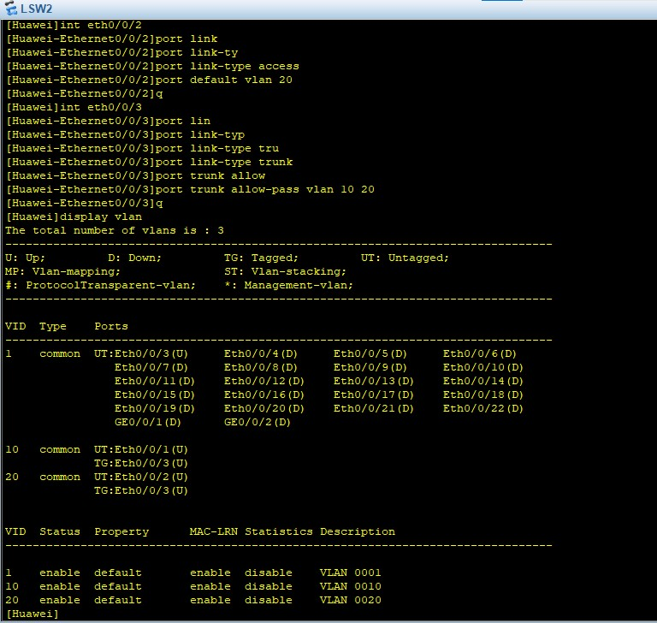

Testing:
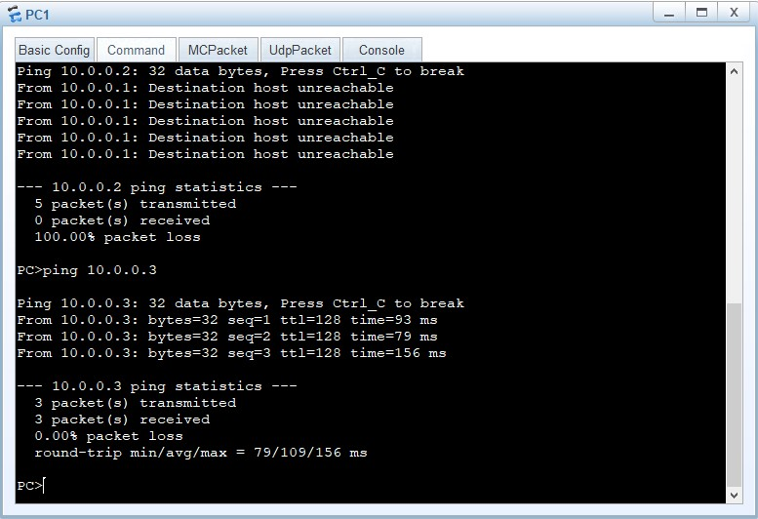
11.5 Conclusions:
Virtual Local Area Networks (VLANs) play a crucial role in modern network design by logically segmenting a physical network into smaller, isolated broadcast domains. This segmentation enhances network performance by reducing unnecessary traffic and improves security by restricting access between different groups of devices. VLANs also provide flexibility, allowing network administrators to organize devices based on function, department, or policy rather than physical location. Overall, VLANs contribute to efficient network management, scalability, and better control over data flow, making them an essential component in enterprise networking.

Experiment (12)
Network Design Using GNS3 Emulator
12.1 Objectives

To achieve usage in GNS3 Emulator

12.2 Equipment / Program Requirements:
GNS3 Emulator

12.3 Experiment Setup:
1- open gns3
2- draw topology
3- ping from device1 to device2
12.4 Simulation Results:

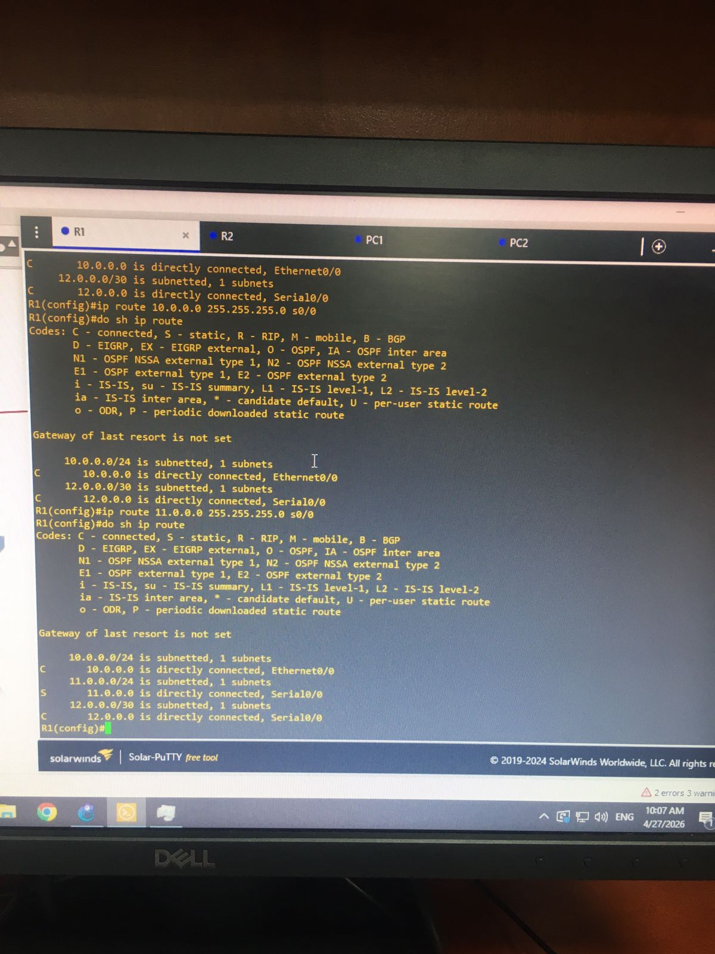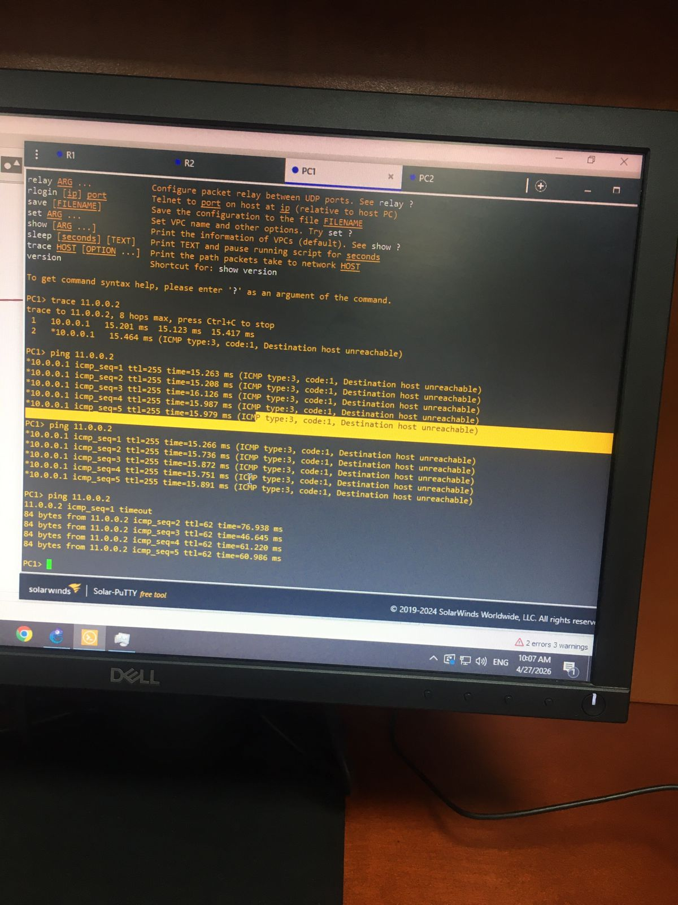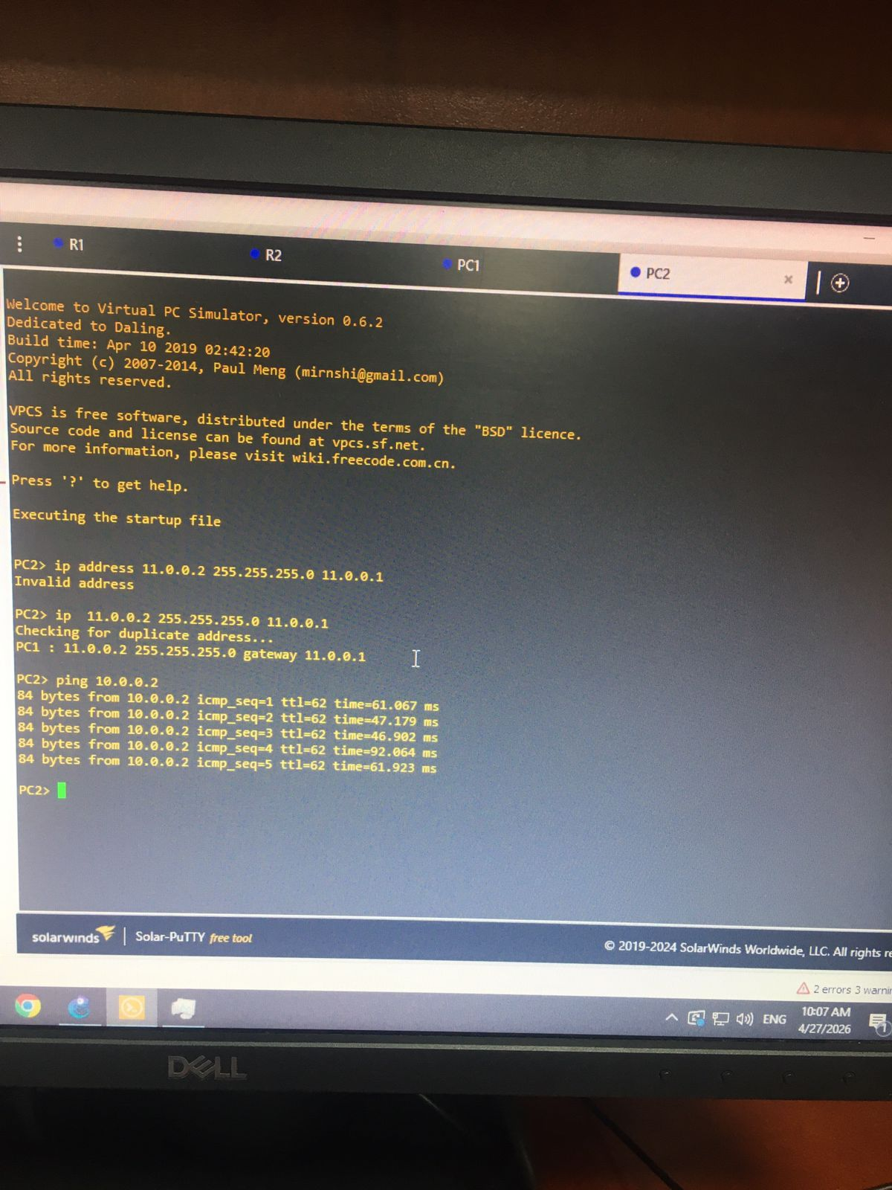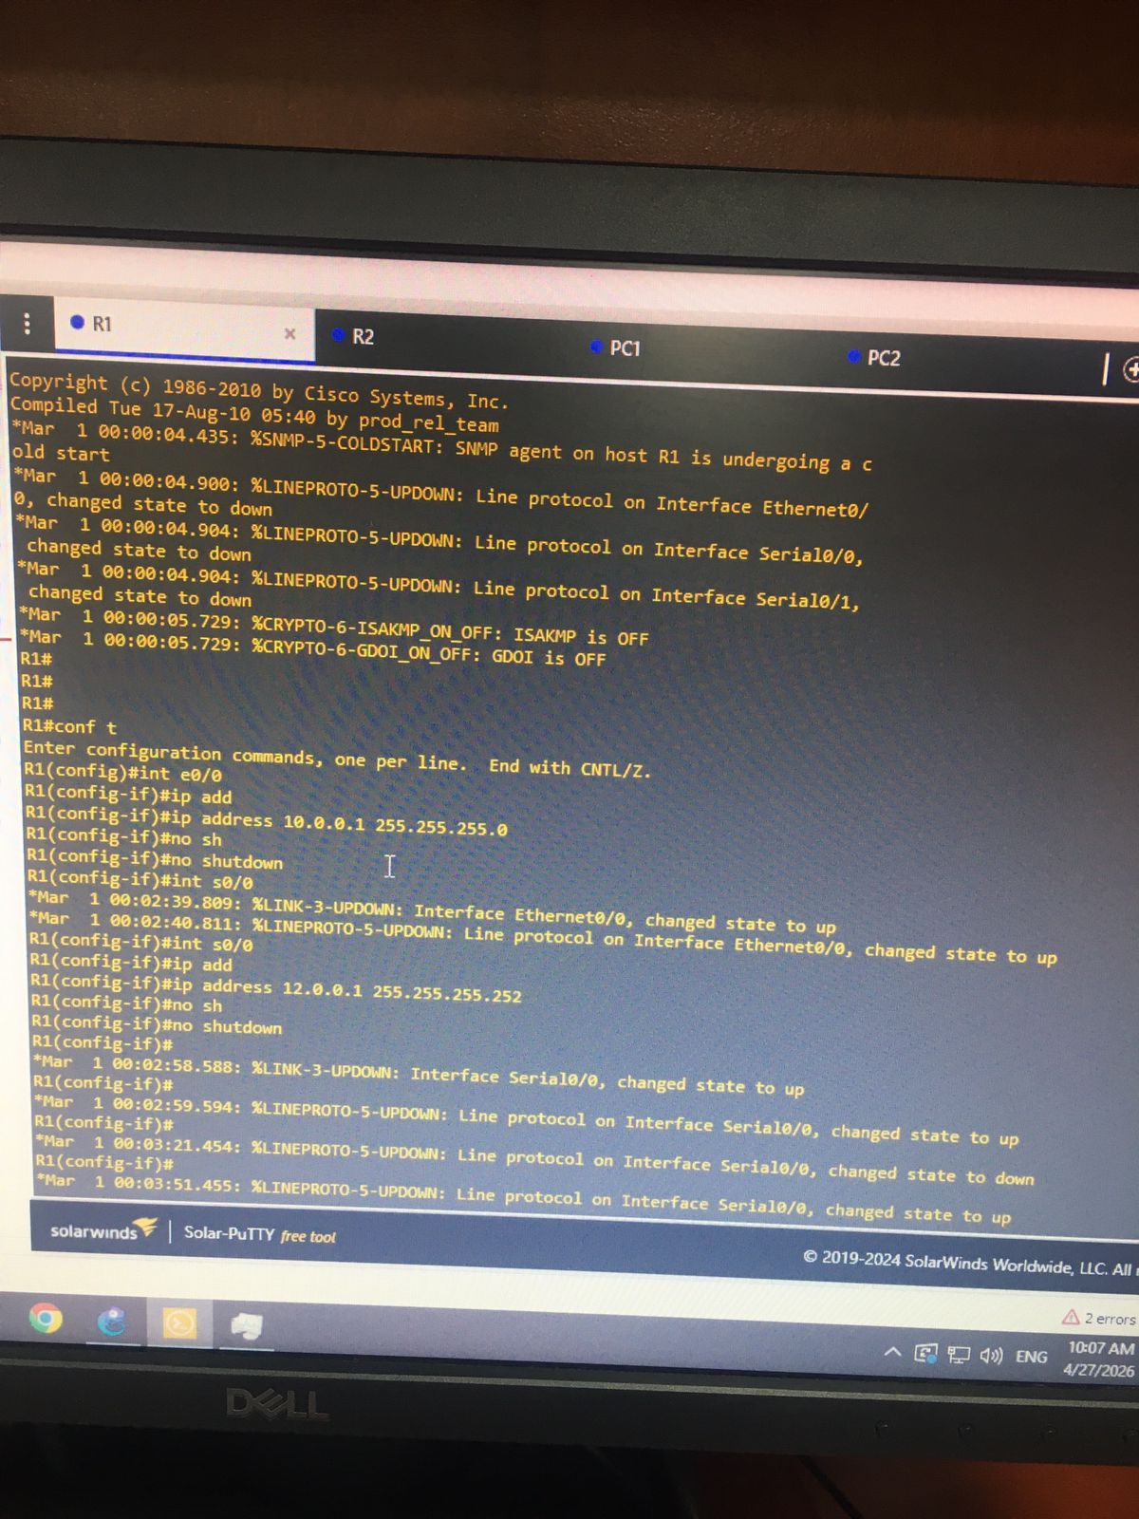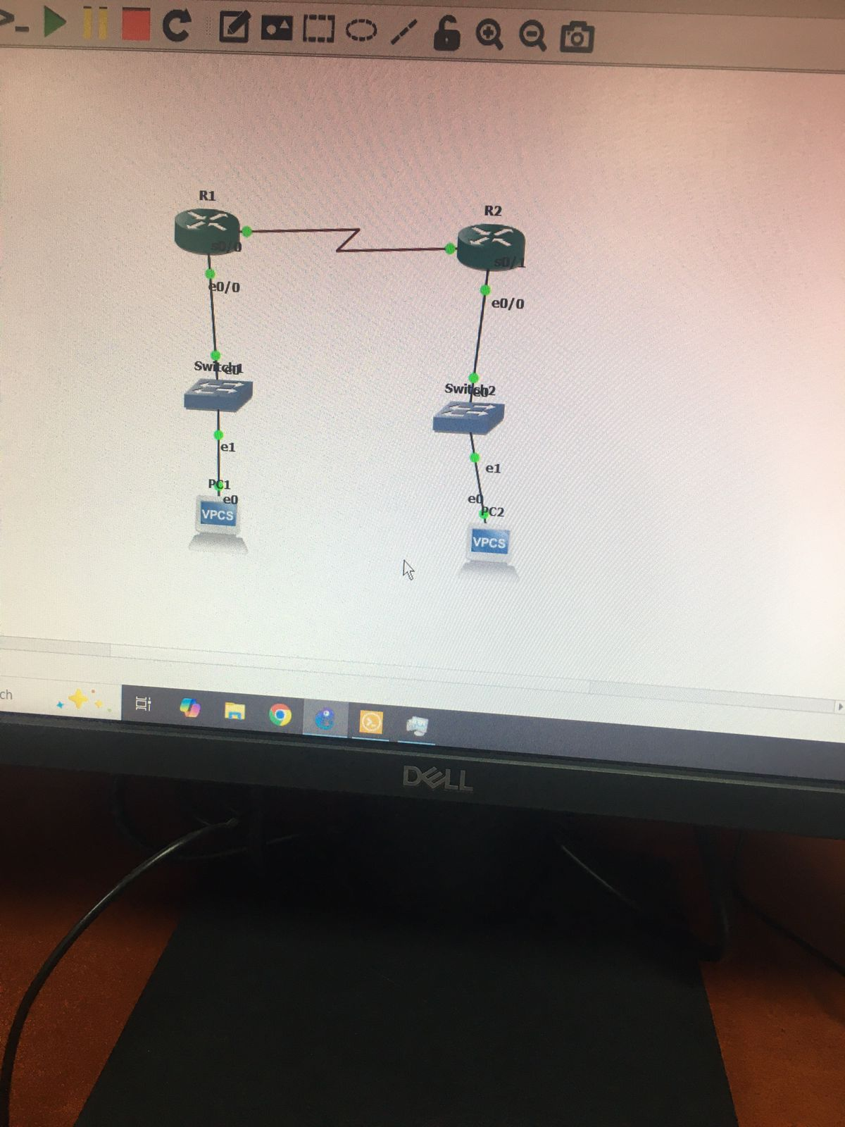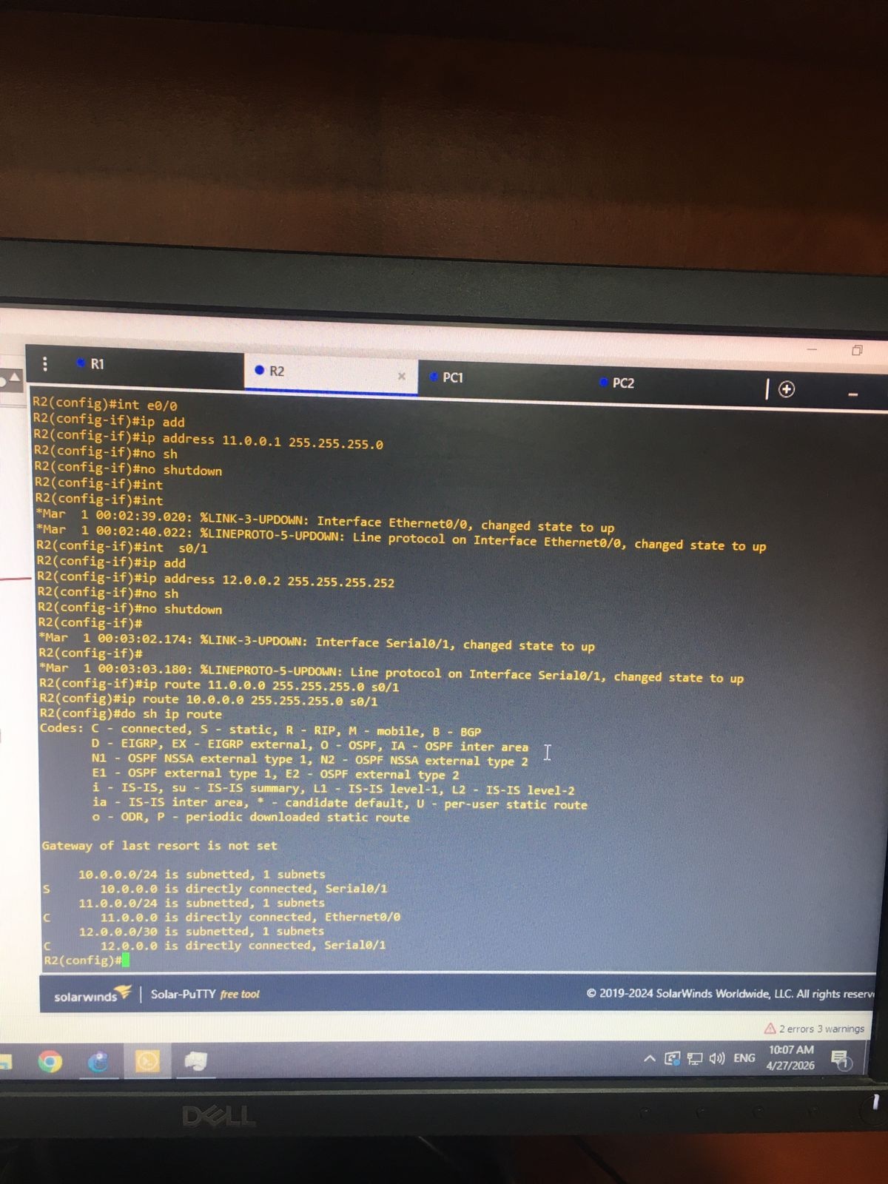

12.5 Conclusions:

In conclusion, GNS3 is a powerful and flexible network simulation platform that allows users to design, configure, and test complex network topologies in a virtual environment. It provides a realistic experience by integrating real network operating systems, which makes it especially valuable for students and network engineers. Additionally, GNS3 supports a wide range of devices and protocols, enabling deep understanding of networking concepts without the need for expensive physical hardware

